**MDF Rose Engine Lathe 2.0**

**with Stepper Motor Drive**



**Instructions for Building**

**Control System for**

**Multiple Stepper Motors**

**Version 2.1**

**14 August 2021**

This document is intended to help one unfamiliar with the MDF rose engine to build one easily. It is designed to go with the kit you can purchase from [www.ColvinTools.com](http://www.ColvinTools.com).

There are some variations from the ideas documented by Jon Magill at [www.rogueturner.com](http://www.rogueturner.com/). Where this is the case, we have tried to document such changes and provide the reason for the change.

This document is also designed to use a stepper motor for driving the spindle.

If you have any questions, please contact us at [ColvinTools@Gmail.com](mailto:ColvinTools@Gmail.com).

Good luck.

Rich Colvin & Jack Zimmel

Table of Contents

Getting Started 4

Overview of Connections 5

Bill of Materials 7

Section 1 – Controls Box Enclosure 12

Before Assembly 13

Assembly 17

Electrical Plates for Connectors 18

Section 2 – Printed Circuit Board 21

Section 3 – Assembly of the Control Box Electronics 30

Mounting the Covers 30

Mounting Electronics to the MDF Base 31

Section 4 – Power Cables 32

Section 5 – Stepper Motor Driver Signal Cables 36

Switch Settings 38

Section 6 – Nextion Display Signal Cable 39

Section 7 – Limit Switch Signal Cables 42

Section 8 – Final PCB Steps 44

Section 9 – Stepper Motor Cables 45

Section 10 – Attaching the Stepper Motor to the Headstock 47

Section 11 – Assembly of the Nextion touch screen Box 49

Attach Nextion Display to the Bezel 49

Section 12 – System Setup and Program Loading 53

Section 13 – Finishing It Up 53

Optional Configurations 54

Option 1: Less Functional Model 54

Option 2: Alternative Stepper Motor Drivers 55

Document Version History 56

# Getting Started

As you get started with building this machine, please consider making the machine according to the outlined instructions. There are a boatload of ways you can modify this, and, quite frankly, the MDF rose engine encourages experimentation, but it is best to attempt those modifications after understanding how it works. Some ideas which sound grand may not appear so after understanding how the machine works (we speak from experience).

If you have any questions on the terminology in this document, check out the “Ornamental Turning Book of Knowledge” ([www.OTBoK.info](https://www.otbok.info/)).

This document outlines the approach for wiring this machine using:

1. Rose Engine Controller Spindle and Three Axes V002c printed circuit board
2. Nextion 4.3” HMI Display, model NX4827K043
3. Teensy 3.5 Microcontroller
4. DM542T Stepper Motor Drivers

Standards are outlined in a companion document and are used for the compilation of this document.

Cautions

1. **Do not perform any changes to this system when the system is powered on.** Power down and unplug the system before attempting any work.
2. If your local electrical code requires for any differences from what is documented here, those requirements take precedence over this document.
3. If you feel uncomfortable with anything in these instructions, consider having a licensed electrician perform the work.

**Please also note:** Permission is not granted to manufacture these for sale.

# Overview of Connections

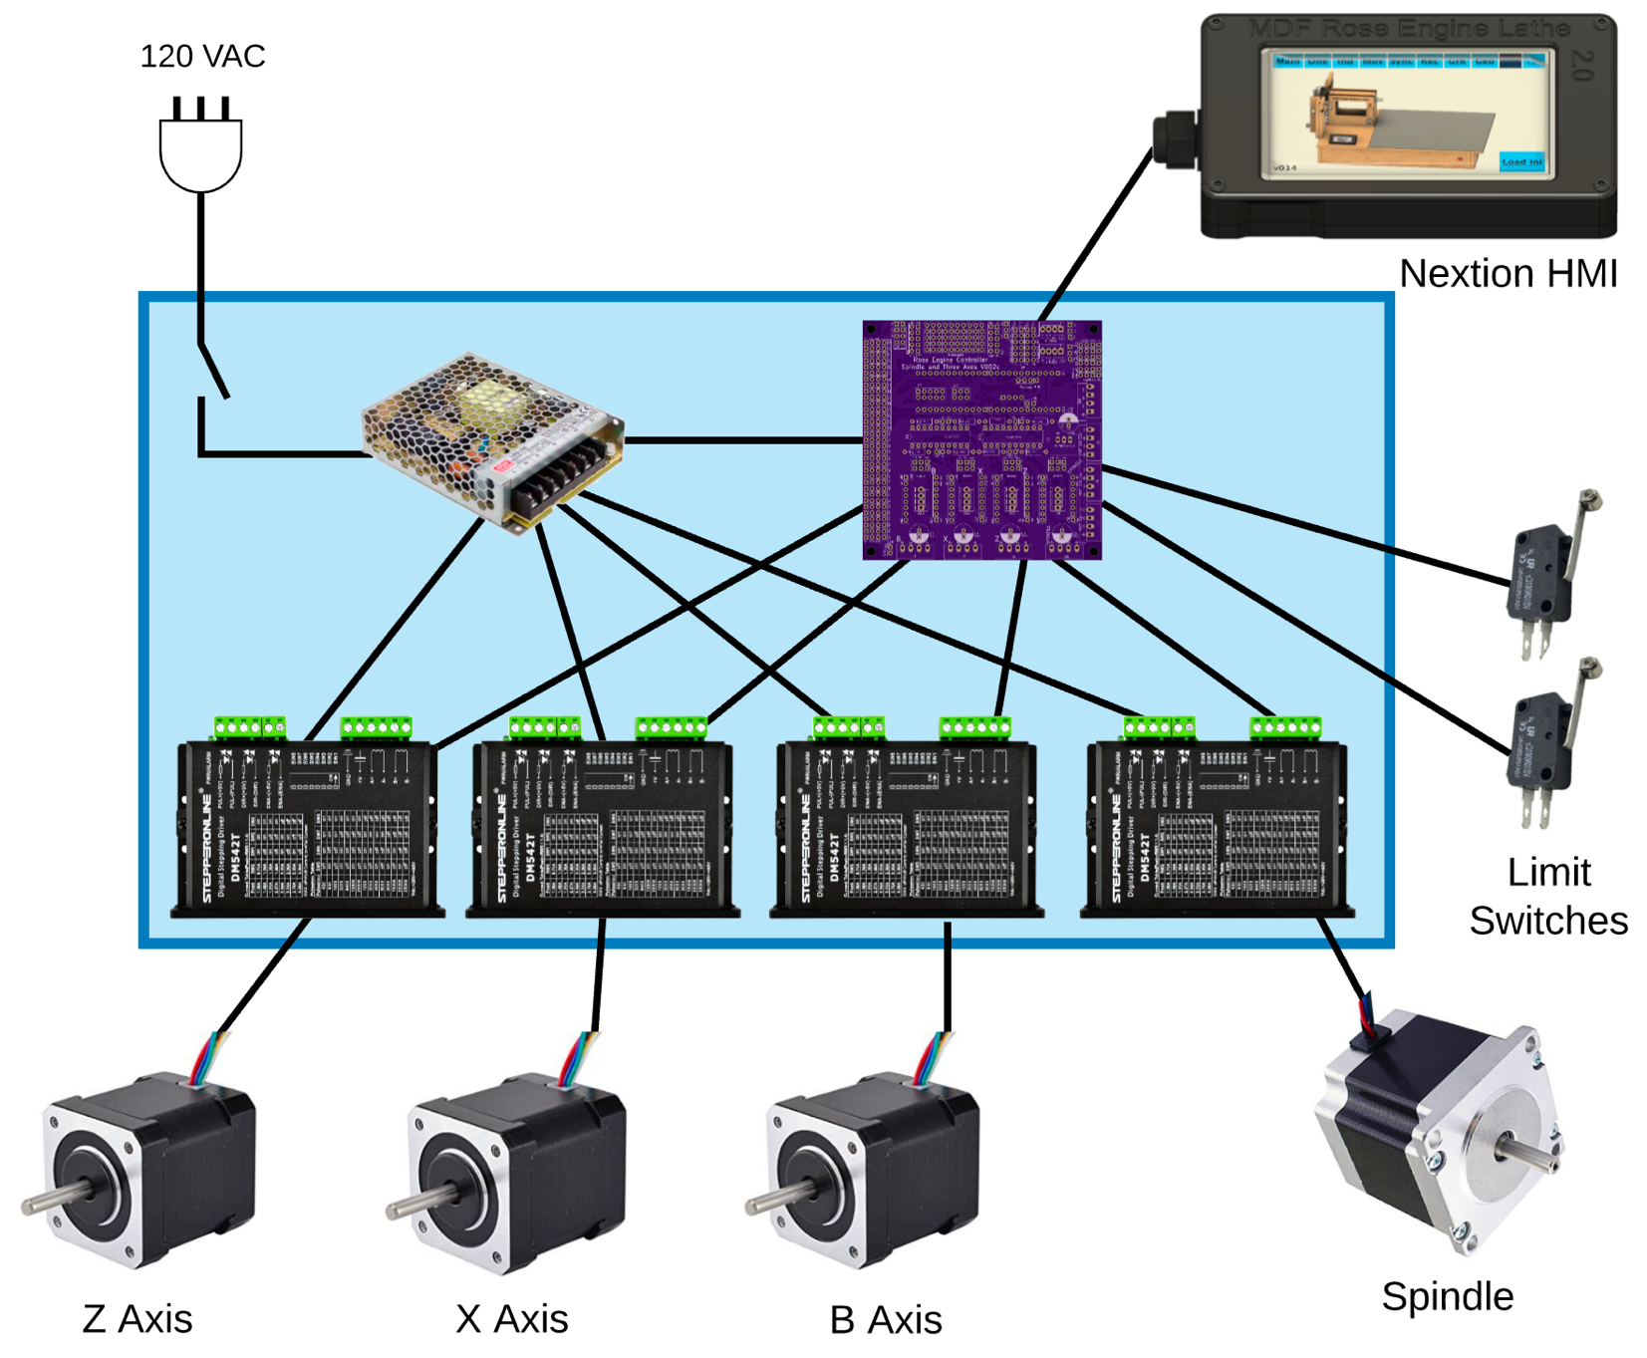The whole system is shown in the picture below.

*Can be added later*

*Can be added later*

The system we supply with the MDF Rose Engine Lathe 2.0 Spindle Drive Option includes:

1. Everything in the Controls Box (the box in blue above)
   1. Power cord and on/off switch
   2. Power supply
   3. Printed Circuit Board with all components attached for 4 drives
   4. Stepper Motor Drivers (4 ea.)
   5. Connectors for
      1. Nextion touch screen
      2. 4 stepper motors
      3. 6 limit and homing switches
2. Nextion touch screen with connecting cable
3. Spindle stepper motor with connecting cable, attaching hardware, drive gears, and drive belt.

The other 3 stepper motors and limit switches (and associated attaching cables) are not included but can be added by the user.

Some have chosen to put the stepper motor controls in the lathe’s carcass, under the bed of the lathe. However, placing all the pieces together in a separate box gives these benefits:



**MDF Rose Engine Lathe 2.0**

**(B1 and B1A removed)**

1. This controls box is designed be placed under the bed in the MDF Rose Engine Lathe 2.0 (as shown in the picture to the right {the bed cover is removed}).
2. This approach also allows for the controls box to be used with the original MDF Rose Engine Lathe, just placing the box somewhere near the lathe.
3. This also frees up space under the bed for:
   1. Storage of parts or tools, or
   2. Making a gap-bed lathe.
4. The many connections between the various pieces inside the box are already in place and the user does not have to figure out the correct alignment of connectors when building the MDF Rose Engine Lathe.
5. The connections to the stepper motors and limit switches are documented as standards. This allows for the creation of attachments (such as a curvilinear slide) with a built-in stepper motor and connecting it to the controls box.

The details for how we are building the one you can buy are below. These are documented for our use to ensure consistency, and we are publishing them for anyone who wishes to build their own.

The sequence of activities follows the layout of this document. That was done consciously. Changes to the sequence should be considered strongly before making changes.

|  |
| --- |
| Bill of Materials |

Parts required for building this are below. The item numbers are shown in the following drawings using an orange, circled number like the one to the right.

| Item # | Item | Qty | Source | Source  Part Number | Comments |
| --- | --- | --- | --- | --- | --- |
|  | **Printed Circuit Board Assembly** |  |  |  |  |
| 101 | Printed Circuit Board (PCB) | 1 | OSH Park | 4Rose_002c_Gerbers copy |  |
| 102 | Header Sockets | 2 | Digi-Key | S7022-ND | 24 pins each  Mfgr p/n PPTC241LFBN-RC |
| 103 | 20-pin DIP sockets | 2 | Digi-Key | ED3054-5-ND |  |
| 104 | 10 KΩ resistors | 8 | Digi-Key | CF14JT10K0CT-ND |  |
| 105 | 100 µF electrolytic capacitor | 1 | LCSC | C59414 | Mfgr p/n KM101M050F115A |
| 106 | 74HCT245 Octal Bus Transceiver, 3-state | 2 | Digi-Key | 296-1612-5-ND |  |
| 107 | R-78E5.0-1.0 DC/DC Converter | 1 | Digi-Key | 945-2201-ND |  |
| 108 | Teensy 3.5 | 1 | PJRC | Teensy 3.5 pins | Be sure to get the one with the pins already soldered into place. |
| 109 | (Unused for this design) |  |  |  |  |
| 110 | (Unused for this design) |  |  |  |  |
| 111 | Header Connector, Vertical, 4 pins, 2.54mm pin spacing | 5 | Digi-Key | WM4113-ND | Used to connect the PCB to:   * Stepper motor drivers (4) * Nextion Display (1)   Molex p/n 0022272041 |
| 112 | Header Connector, 90 degree, 4 pins, 3.50mm pin spacing | 1 | Digi-Key | 277-2419-ND | Used to connect power to the PCB.  Phoenix Contact p/n 1844236 |
| 113 | Header Connector, Vertical, 12 pins (6x2), 2.54mm pin spacing | 1 | Digi-Key | 609-5695-ND | Used to connect jacks for limit switches to the PCB.  Amphenol ICC p/n 77313-101-12LF |
| 114 | Header Connector, Vertical, 2 pins, 2.54mm pin spacing | 1 | Digi-Key | SAM12303-ND | Used for setting the power selection for the Nextion touch screen.  Samtec p/n TSW-102-24-T-S |
| 115 | Mini Jumper | 1 | Digi-Key | 664-G89011020023DEU-ND | Used for setting the power selection for the Nextion touch screen.  Amphenol p/n G89011020023DEU |

| Item # | Item | Qty | Source | Source  Part Number | Comments |
| --- | --- | --- | --- | --- | --- |
|  | **Electrical Items** |  |  |  |  |
| 201 | AC/DC Power Supply - LRS-100-24 | 1 | Digi-Key | 1866-3314-ND |  |
| 202 | DM542T Stepper Driver | 4 | StepperOnline | DM542T |  |
| 203 | Nextion 4.3” HMI Enhanced | 1 | ITEAD.cc | NX4827K043 | If that model is not available, select the replacement which has:   * Resistive touch (vs. capacitance) * Flash data storage space: 32MB or more * EEPROM: 1024 bytes or more * RAM: 8192 bytes or more * Instruction buffer: 1024 bytes or more * Resolution: 480×272 pixel |
| 204 | Terminal Block, 10 circuits, low profile | 1 | Mouser | 538-39100-1910 | Used to distribute power from the LRS-100-24 (#201) to the other parts in the box.  Molex p/n 39100-1910 |
| 205 | Power Switch | 1 |  |  | SPST Toggle |
| 206 | GX-16/ 4 Socket | 4 | Amazon |  | Used to connect stepper motors to stepper motor drives.  May come as a pair of sockets and plugs (i.e., including #214) |
| 207 | 3.5mm Audio Jack, Female | 6 |  |  | Used for connecting limit switches. |
| 208 | Utility box cover, 2 gang | 2 |  | Hubbell-Raco 804C |  |
| 209 | Utility box cover, 1 gang | 1 |  | Hubbell-Raco 861 |  |
| 210 | Utility box cover, 1 gang | 1 |  | Hubbell-Raco 860 |  |
| 211 | 3/8 in. Twin-Screw Cable Clamp Connectors | 1 |  |  | Used for the AC power cable. |
| 212 | Cord Grip | 1 | McMaster-Carr | 69915K47 | Used for the cable to the 3D-printed case for the Nextion display. If hard wiring the cable to the main box, a 2d one of these is needed. |
| 213 | Stepper Motor | 1 | StepperOnline | 23HS30-30045 | For the spindle drive: NEMA 23 bipolar 1.8°, 1.9 Nm, 2.8A, 3.2V, 57mm x 57mm x 76 mm |
| 214 | GX-16/ 4 Plug | 1 | Amazon |  | Used for stepper motors.  May come as a pair of sockets and plugs (i.e., including #206) |
| 215 | GX-12/ 4 Socket | 1 | Amazon |  | Used for the Nextion touch screen display.  May come as a pair of sockets and plugs (i.e., including #216) |
| 216 | GX-12/ 4 Plug | 1 | Amazon |  | Used for the Nextion touch screen display in lieu of RJ-45 connectors.  May come as a pair of sockets and plugs (i.e., including #215) |
| 217 | Connector Housing Receptacle, 2.54mm pin spacing | 5 | Digi-Key | WM2002-ND | Used to connect the PCB to:   * Stepper motor drivers (4) * Nextion Display (1)   Molex p/n 0022013047 |
| 218 | Terminal Block Plug, 4 pins, Screw Terminals, 3.50mm pin spacing | 1 | Digi-Key | 277-2418-ND | Used to connect power to the PCB.  Phoenix Contact p/n 1840382 |

| Item # | Item | Qty | Source | Source  Part Number | Comments |
| --- | --- | --- | --- | --- | --- |
|  | **Cables** |  |  |  |  |
| 301 | Cabling – CAT 5 or higher |  |  |  | Used for the Nextion touch screen. |
| 302 | Cabling – 20 AWG/4, stranded |  |  |  | Used for signaling for the stepper motors and the stepper motor drivers. |
| 303 | Cabling – 20 or 22 AWG/2, stranded or solid core |  |  |  | Used for low voltage, DC power. |
| 304 | Cabling – 16 AWG/3, stranded |  |  |  | Used for AC power. Can cut off the female end of a grounded extension cord. |
| 305 | Cable with Connector, 2 pin, 2.54mm pin spacing, 500mm long (19 ½”) | 3 | Digi-Key | 1175-1261-ND | Used for limit switches. Both ends have connectors, so cable will be cut in the center to make two each.  CNC Tech p/n 810-10053-00050 |
|  | Cable, pre-crimped on one end for Molex connector (#217), 10” long, 28 AWG, |  |  |  | Used to connect the PCB to the GX-12/4 socket for the Nextion touch screen. |
| 306 | * White | 1 | Digi-Key | 0008500113-10-W8-ND | Molex p/n 08500113-10-W8 |
| 307 | * Orange | 1 | Digi-Key | 0008500113-10-A8-ND | Molex p/n 08500113-10-A8 |
| 308 | * Green | 1 | Digi-Key | 0008500113-10-G8-ND | Molex p/n 08500113-10-G8 |
| 309 | * Blue | 1 | Digi-Key | 0008500113-10-L8-ND | Molex p/n 08500113-10-L8 |
| 310 | Crimp Terminal | 16 | Digi-Key | WM2312-ND | Used to connect the PCB to the DM542T stepper motor drivers.  Molex p/n 08550102 |

| Item # | Item | Qty | Source | Source  Part Number | Comments |
| --- | --- | --- | --- | --- | --- |
|  | **Screws, etc.** |  |  |  |  |
| 401 | Nylon Spacer (Unthreaded) for #8 screw – ¼” OD, ¼” length | 4 | McMaster-Carr | ﻿94639A293 | Used to raise the PCB up off the MDF. |
| 402 | Brass Heat-Set Inserts for Plastic, #4-40, 0.170” | 4 | McMaster-Carr | 94459A260 | If you take option #1 as outlined on pg. 50, you should use these. If not, they are not needed. These go with #403, below. |
| 403 | Screws, #4-40, ¾” | 4 | McMaster-Carr | 97763A322 | If you take option #1 as outlined on pg. 50, you should use these. If not, they are not needed. These go with #402, above. |
| 404 | M3 Screws, Thread Forming | 4 | McMaster-Carr | 96817A300 | Used to attach the Nextion touch screen display to the 3D printed case. |
| 405 | Magnets | 4 | McMaster-Carr  or Amazon | 5862K14 | ½” outside diameter with hole in center for attaching to an object via a screw. Used on bottom of the 3D-printed enclosure for the Nextion touch screen display |
| 406 | Sheet Metal Screws, #4, 3/4” long, round head |  | McMaster-Carr | 90935A137 | These work acceptably in the MDF for the purposes they are designed to be used. |
| 407 | Particle Board Screws, #6, 3/4” long, round head |  | McMaster-Carr | 91555A115 |  |
| 408 | Particle Board Screws, #6, 5/8” long, flat head |  | McMaster-Carr | 90252A246 | Used to attach #208, #209, and #210 to the MDF. |
| 409 | Sheet metal screws, #4, 5/16” long, flat head |  | McMaster-Carr | 90065A107 | Used to attach #405 magnets to the 3D-printed enclosure for the Nextion touch screen display. |
| 410 | Torx Round Head Thread-Forming Screws for Plastic, #4, 7/8” long |  | McMaster-Carr | 96001A217 | If you take option #2 as outlined on pg. 50, you should use these. If not, they are not needed. |

| Item # | Item | Qty | Source | Source  Part Number | Comments |
| --- | --- | --- | --- | --- | --- |
|  | **Spindle Drive Parts** |  |  |  |  |
| 501 | Timing Belt | 1 | MiSUMi | GBN655EV5GT-90 | * GT3 5mm pitch * 131T / 655mm long * 9mm wide |
| 502 | Spindle Pulley | 1 | Colvin Tools |  | Attached to the spindle via the flange. |
| 503 | Stepper Motor Pulley | 1 | Stock Drive Products ([www.sdp-si.com](http://www.sdp-si.com)) | A 6A55-012DF0908 | Aluminum Alloy Timing Pulley for .354 (9mm)" Wide Belt   * 5 mm (GT2) Pitch * 12 Teeth * 0.25" Bore * 2 Flanges / With Hub   Attached to the stepper motor |
| 504 | Stepper Motor Attachment Bracket & Parts | 1 | Colvin Tools |  | Includes:   * Bracket with Idler * Mounting bolts, nuts, and spacers to attach to headstock * Mounting screws to attach stepper motor |

| Item # | Item | Qty | Source | Source  Part Number | Comments |
| --- | --- | --- | --- | --- | --- |
|  | **Touch Screen Parts** |  |  |  |  |
| 601 | Touch Screen Case, 3D printed | 1 | Colvin Tools |  | Can also get plans to 3D print this from **elfren**’s repository on GitHub. The folder is  **RoseEngine_SpindleAndAxis / Nextion / Enclosure_43** |

Not all screws are shown, only the ones which matter for size or are hard to find.

| Item # | Item | Qty | Source | Source  Part Number | Comments |
| --- | --- | --- | --- | --- | --- |
|  | **Optional Parts** |  |  |  |  |
| 901 | Limit switch | Up to 6 | McMaster-Carr | 7779K13 | Needs to be normally off with a momentary on. |
| 902 | Magnetic Base Stand with Noga Arm |  | Amazon |  | For holding the limit switch. Clockwise Tools MGBR-01 is a good one to consider. |

|  |
| --- |
| Section 1 – Controls Box Enclosure |

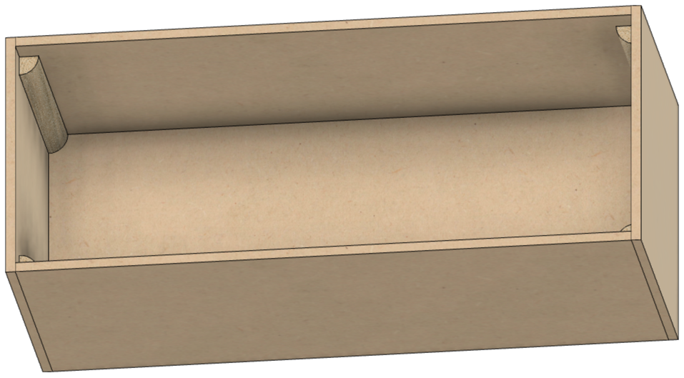

**Bottom**

**Side**

**Side**

**Side**

**Side**

The assembled box has

1. A top and bottom made from ¾” MDF,
2. Four sides made from ¼” MDF, and
3. 4 corner posts made from quarter-round trim (these are recommended but not required. The box can be assembled without them).

Removing the top reveals the interior of the box as shown to the right.

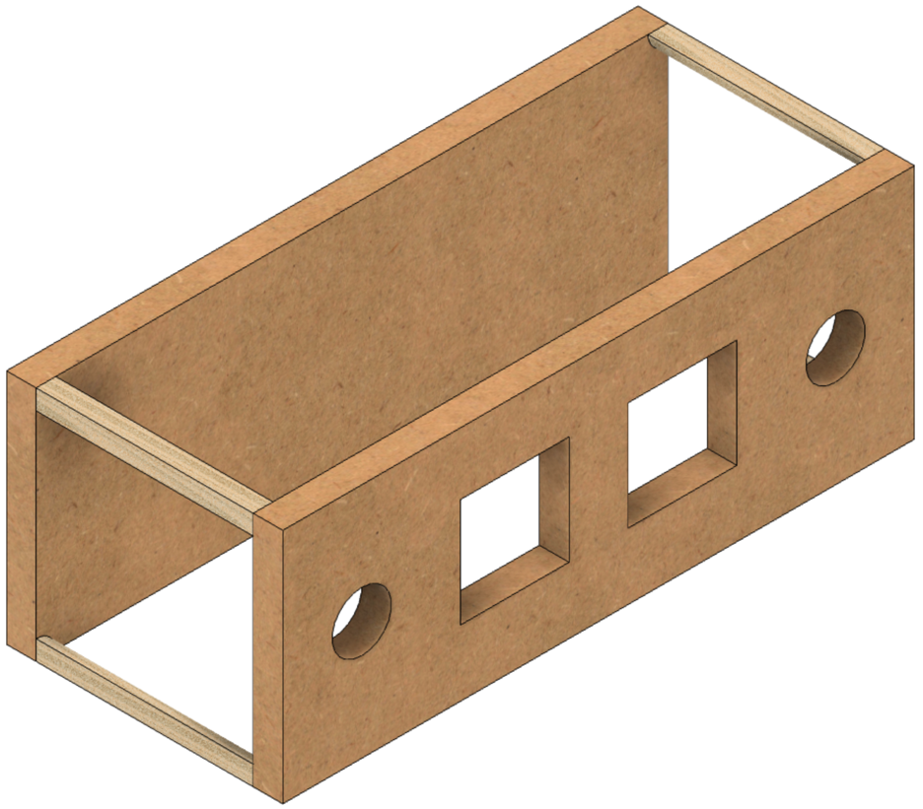

**Top**

**Bottom**

The quarter-rounds are used to give the top and bottom something to set the spacing correctly.

The four ¼” thick sides are screwed to the ¾” MDF used for the top and bottom.

Replacing the top, and removing the sides reveals the view to the left.

## Before Assembly

The following instructions should be followed before assembling the controls box

### Bottom

This is made from ¾” MDF.

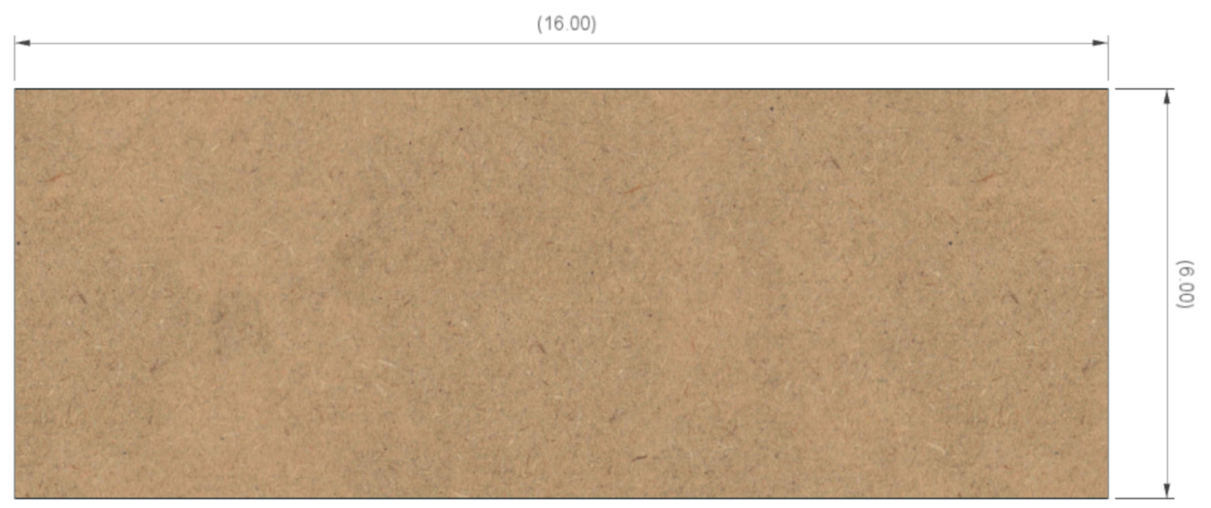

**6”**

**16”**

### Top

1 ½” dia (typ)

This is made from ¾” MDF.

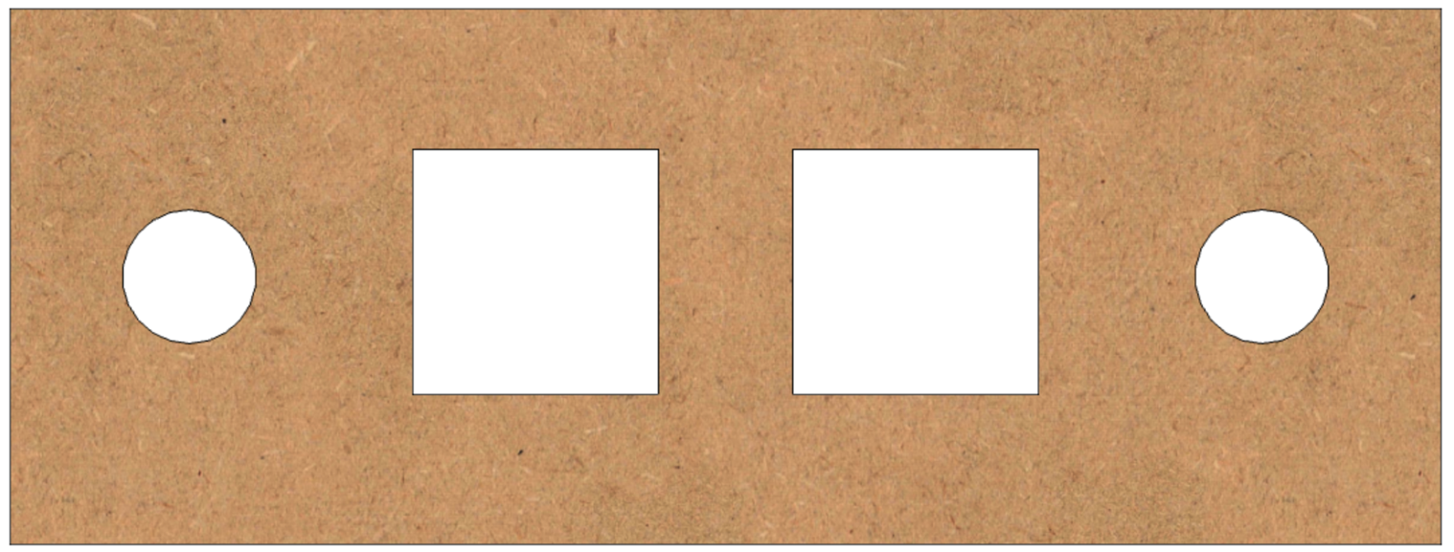

3”

2 ¾”

2 ¾”

6”

2”

2”

2 ¾”

4 ½”

2 ¾”

4 ½”

16”

### Long Sides (2)

There are two of these, and they are made from ¼” MDF.

**16”**

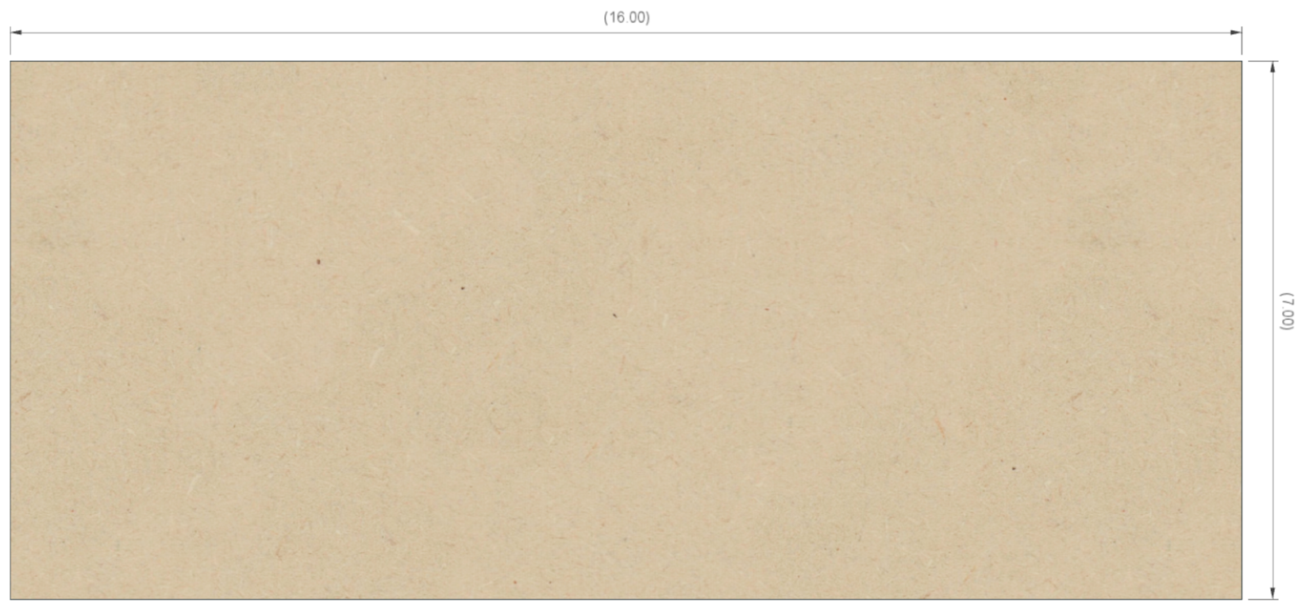

**6 ½”**

### Short Sides (2)

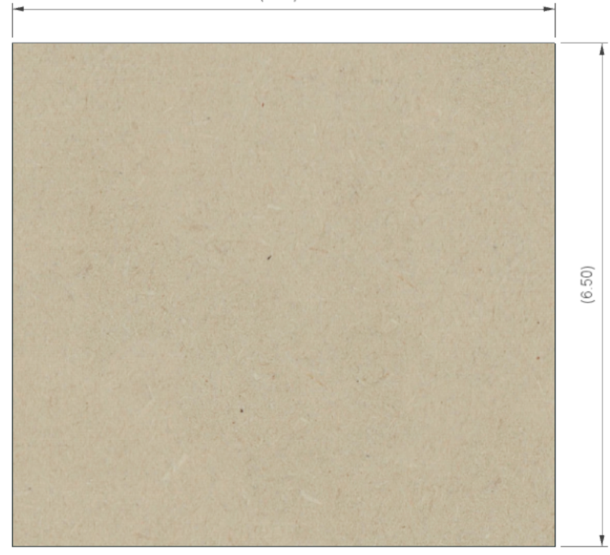

**6 ½”**

**6 ½”**

There are two of these, and they are made from ¼” MDF.

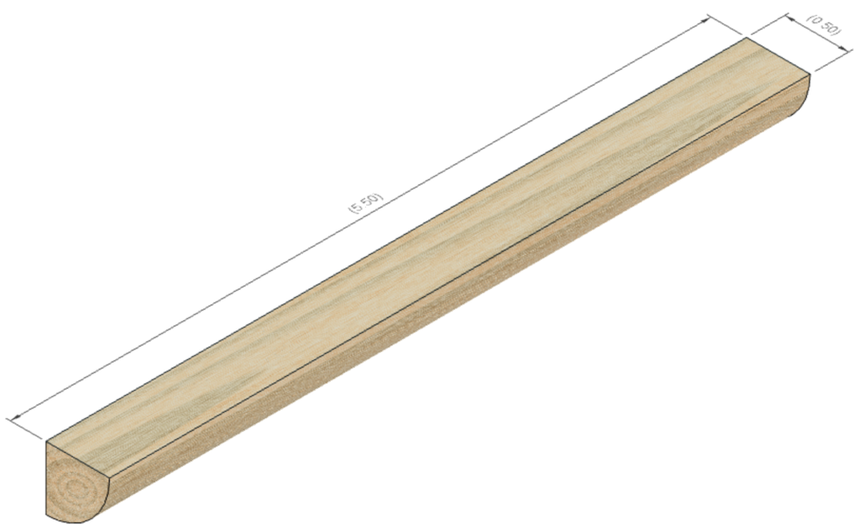

**5”**

**½”**

### Quarter Rounds (4)

There are four of these, and they are made from any good trim material. These are ½” radius, but that is not terribly critical.

## Assembly

Glue the four quarter rounds to the ends of the two long sides. Be certain to:

1. center the quarter round so there is ¾” on each end, and
2. ensure the edges are flush to each other.

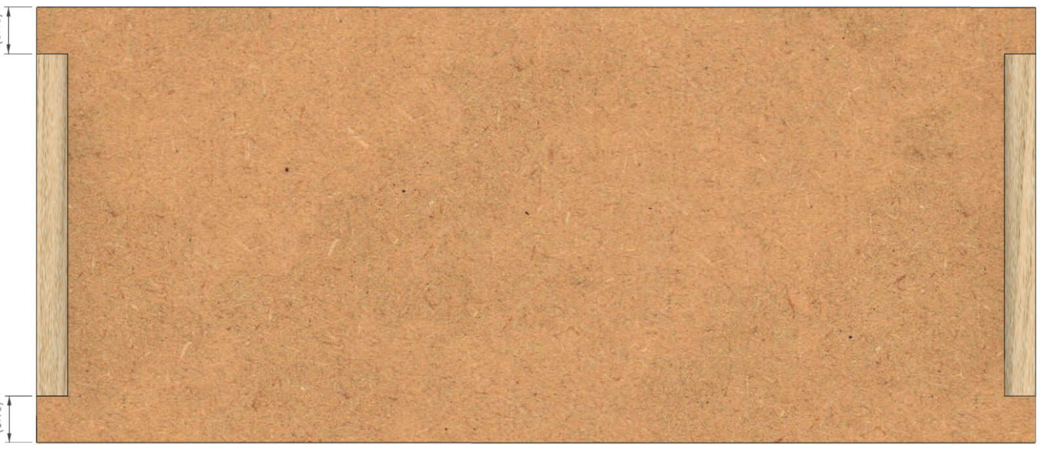

**¾”**

**¾”**

## Electrical Plates for Connectors

### A close up of a speaker Description automatically generatedPower Infeed

Use a 1-gang plate with the hole punched out for the cable strain relief. Secure the power cable in place using the 3/8 in. Twin-Screw Cable Clamp Connector. Wait until later to tighten the screws holding the power cable into place.

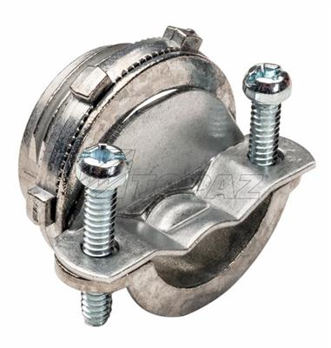

### A computer generated image of a speaker Description automatically generatedPower Switch

****Use a 1-gang plate which is blank. Drill a ½” hole in the center and secure the power switch to it.

### Stepper Motor Plugs



1 ¾”

1 ¾”

**Spindle**

**X Axis**

**Z Axis**

**B Axis**

Use a 2-gang plate which is blank. Drill 4 holes which are each 5/8” diameter.

Label these as:

* Z Axis
* B Axis
* X Axis
* Spindle

### A picture containing sitting, indoor, old, photo Description automatically generatedOther Plugs

**Limit Switches**

**36**

**34**

**35**

**39**

**37**

**38**

**Touch Screen**

1”

1”

1”

1”

¾”

Use a 2-gang plate which is blank.

Drill 6 holes which are each 6mm or 15/64” diameter. Label these as:

|  |
| --- |
| **Limit Switches** |
| **34 35 36** |
| **37 38 39** |

Those numbers represent the pins on the Teensy.

For the touch screen (the Nextion touch screen), the recommended approach is to use a connector like a GX-12/4 (#215) to connect the wires. For that connector, drill the hole using a 12mm bit. Center it left to right and 1” from the outer edge. Label this as:

**Touch Screen**

|  |
| --- |
| Section 2 – Printed Circuit Board |



Attach the parts to the **Rose Engine Controller Spindle and Three Axes V002C** printed circuit board (PCB) using the instructions below.

Once all the parts are in place, it will look like this

(the color difference between this and the following pages is due to the camera flash on my iPhone)

### Through-Hole Components, part 1

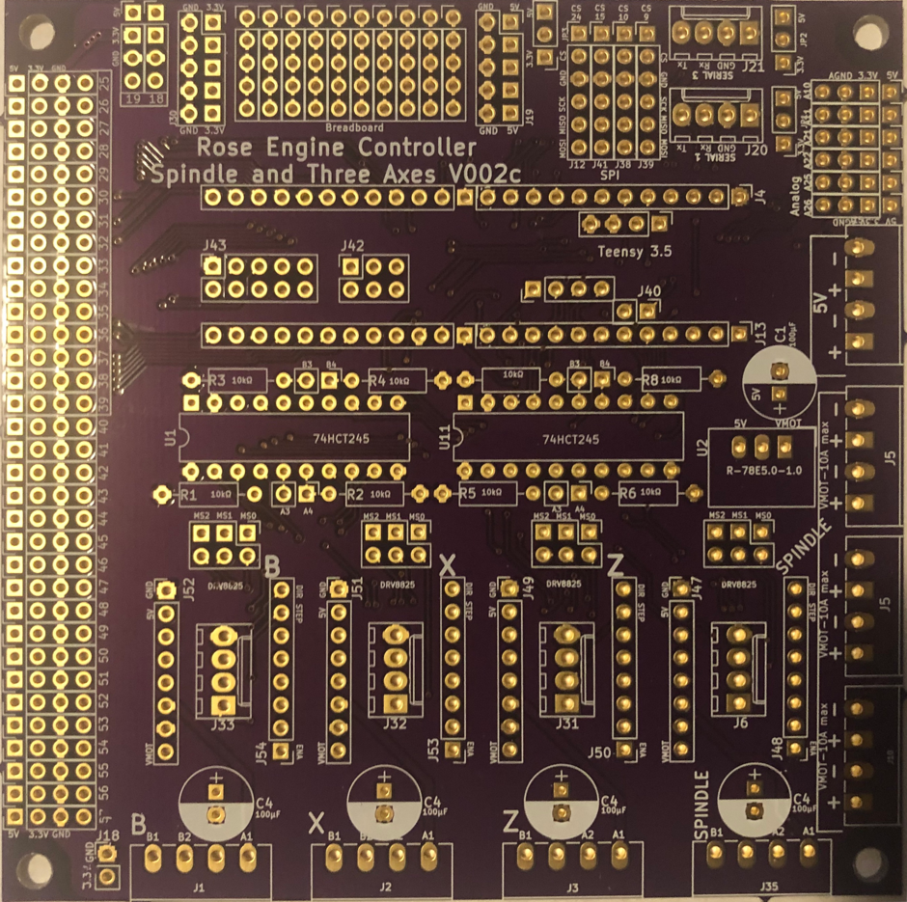Solder in the resistors as noted below.

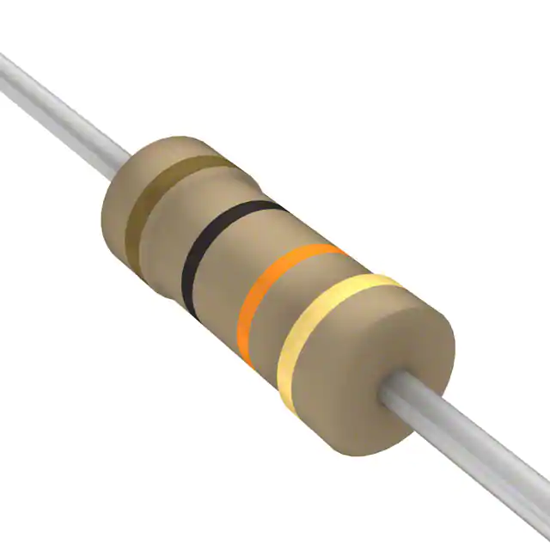

10 KΩ resistors (8)

**NOTE:** the direction in which these are installed is not critical, but I solder them in place the same for each side. Makes it look more dress-right-dress. (My SGT would be happy.)

### Headers for Integrated Circuits

Solder in the 2 headers for the Teensy, and the 2 DIP sockets for the integrated circuits.

Headers (2) for Teensy 3.5

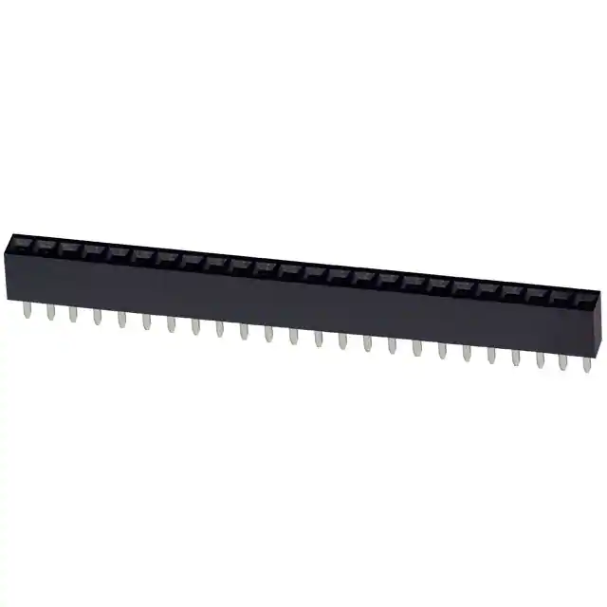

**NOTE:** The headers must be at 90° to the circuit board. It is necessary to ensure that they remain perpendicular or the Teensy’s pins will not fit into the header pin holes.

20-pin DIP sockets (2) for 74HCT245s

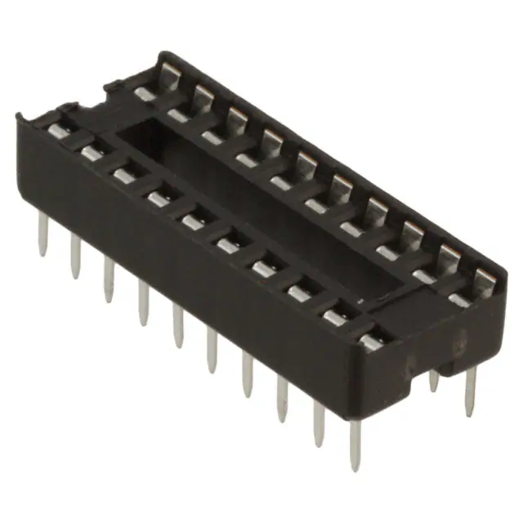

**NOTE:** Both sockets have direction indicators on them. Ensure they match the direction indicators on the board (the little curved part of the marking on the board). This is to ensure the 74HCT245s are inserted correctly.

### Power Header Connector

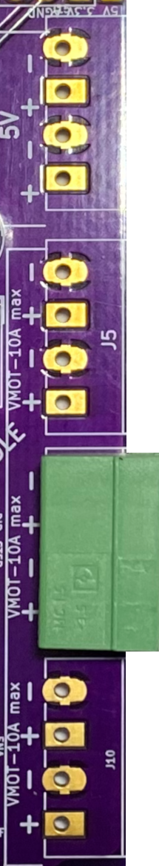Solder in the power connector as noted below.

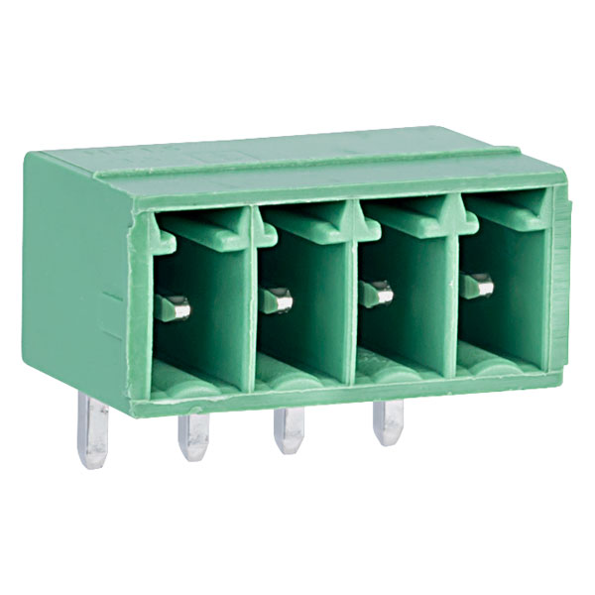

Header Connector, 90 degree, 4 pins, 3.50mm pin spacing

**NOTE 2:** The connector’s pins (the side shown above) should point toward the outside of the PCB.

**NOTE 1:** Either J5 could be used. Using this one makes later work easier.

**As Installed**

### A picture containing electronics Description automatically generatedText Description automatically generated with medium confidenceNextion Display Header Connectors

Header Connector, vertical, 2 pins, 2.54mm pin spacing

Solder in the power and signal connector as noted below. 

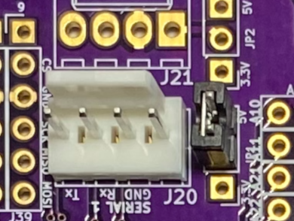

**NOTE:** The plastic tab projecting up from the connector should be aligned with this marking on the PCB.

Mini Jumper – Installed across pins in header connector #114.





**As Installed**

Header Connector, vertical, 4 pins, 2.54mm pin spacing

### A circuit board Description automatically generatedStepper Motor Driver Header Connectors

Header Connector, vertical, 4 pins, 2.54mm pin spacing

Solder in the stepper motor driver connectors as noted below.

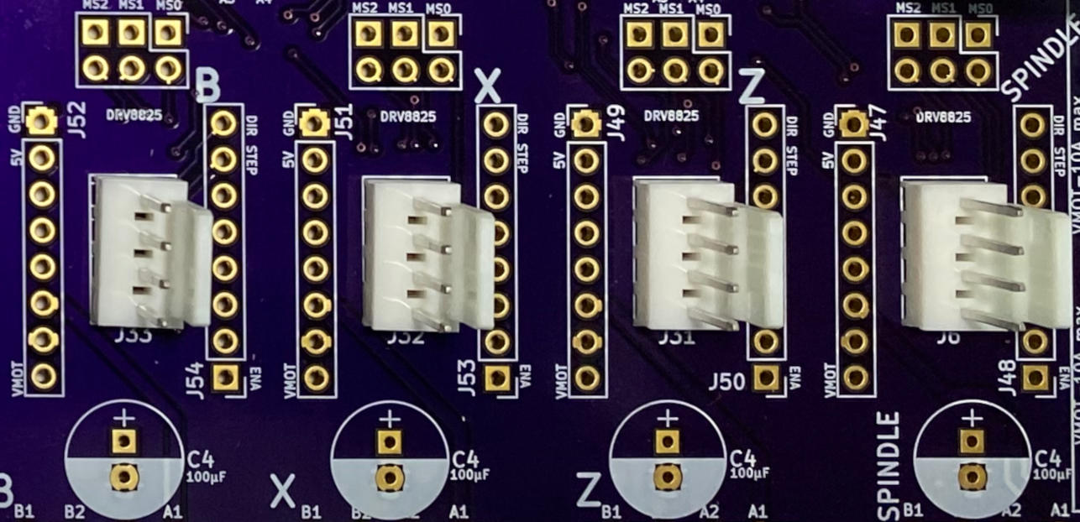

**NOTE:** The plastic tab projecting up from the connector should be aligned with this marking on the PCB.



**As Installed**



### Limit Switch Header Connectors

Solder in the limit switch connector pins as noted below.

**NOTE:** Second connector is used on pins 34-39.

**NOTE:** One connector is used on pins 25-30.



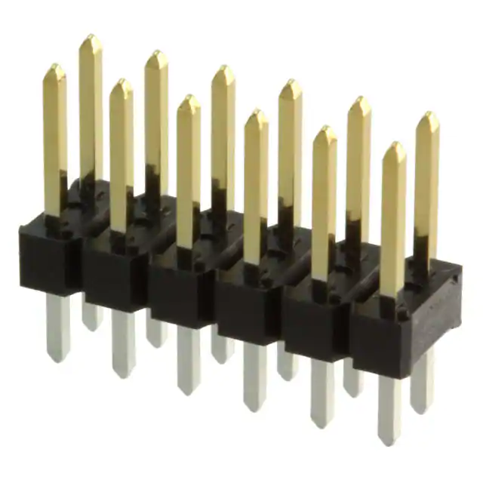

Header Connector, vertical, 12 pins (6x2), 2.54mm pin spacing

The original design only used pins 34-39; however, this board and the Teensy can use pins 18, 19, and 25-39.

If you choose to connect a microSD extender to the Teensy, pins 29-37 need to be left unused or the limit switch connectors will interfere.

**As Installed**

**NOTE:** Be sure the capacitor is set correctly. The negative (–) side goes in the area shaded white.

### Through-Hole Components, part 2

Solder in the components noted below.

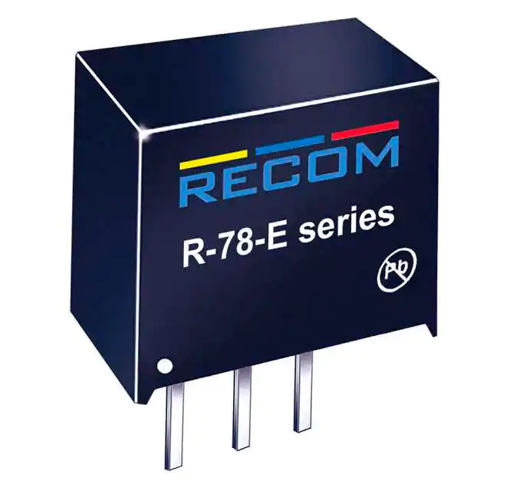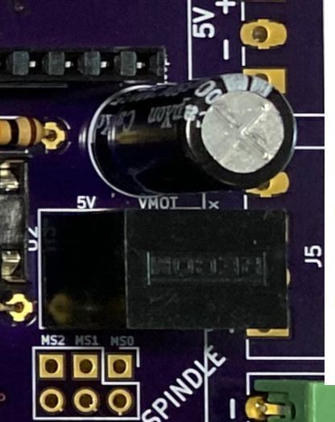

100 µF Capacitor

**As Installed**

**As Installed**

R-78E5.0-1.0 DC DC Converter

**NOTE:** The DC converter should fit over the box printed for it on the board.

Once all the parts are in place, it will look like this.

(the color difference is due to the camera flash on my iPhone)

|  |
| --- |
| Section 2 AddendumNextion Intelligent Display and Teensy 3.6 |

When using the **Teensy 3.6** with a **Nextion Intelligent** series display, there is a concern that the Nextion HMI could supply 5V back to the Teensy. The Teensy 3.6 can only handle 3.3V so some additional wiring is needed. (This is why the Teensy 3.5 is recommended – it can handle 5V.)

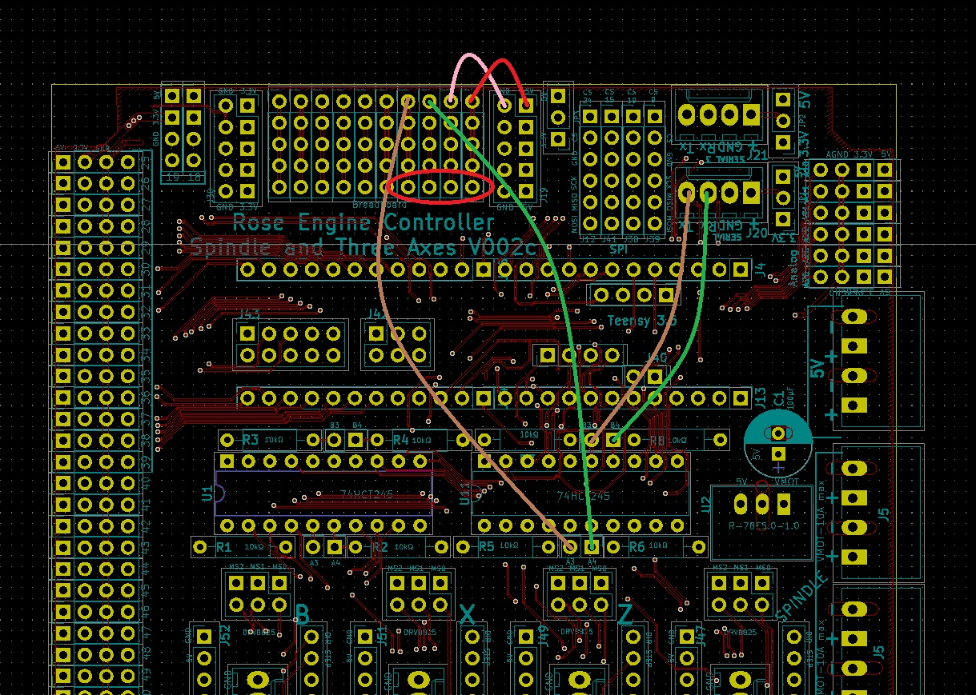If that is the approach you are using, an additional header connector and additional wiring is recommended on the PCB as noted below.



Add a new header connector at this location for connecting the Nextion Intelligent display to the PCB. These are breadboard wiring locations, and each vertical row is connected in the PCB.

And add the 6 wires noted in the drawing above.

|  |
| --- |
| Section 3 – Assembly of the Control Box Electronics |

## Mounting the Covers

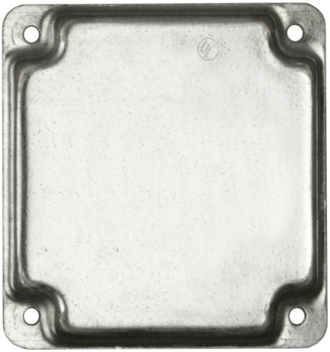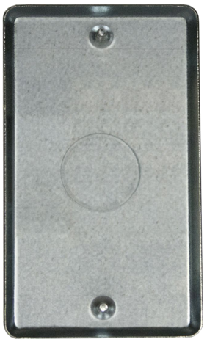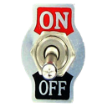The layout below is recommended. This minimizes cable management issues when used.

**Touch Screen**

**Limit & Home Switches**

**36**

**34**

**35**

**39**

**37**

**38**

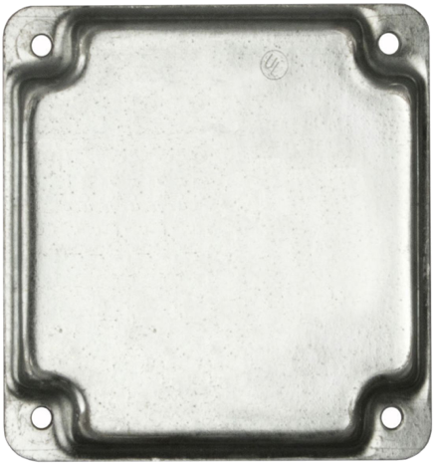

**Spindle**

**X Axis**

**Z Axis**

**B Axis**

**NOTE:** Screw these plates into place using 5/8” #6, flat head, particle board screws (item #408 in the bill of materials).

## Mounting Electronics to the MDF Base

Mount the electronics to the base piece of the MDF. The PCB is secured to the MDF with the ¼” spacers under the 4 corners to place the board so that there is a ¼” gap below.

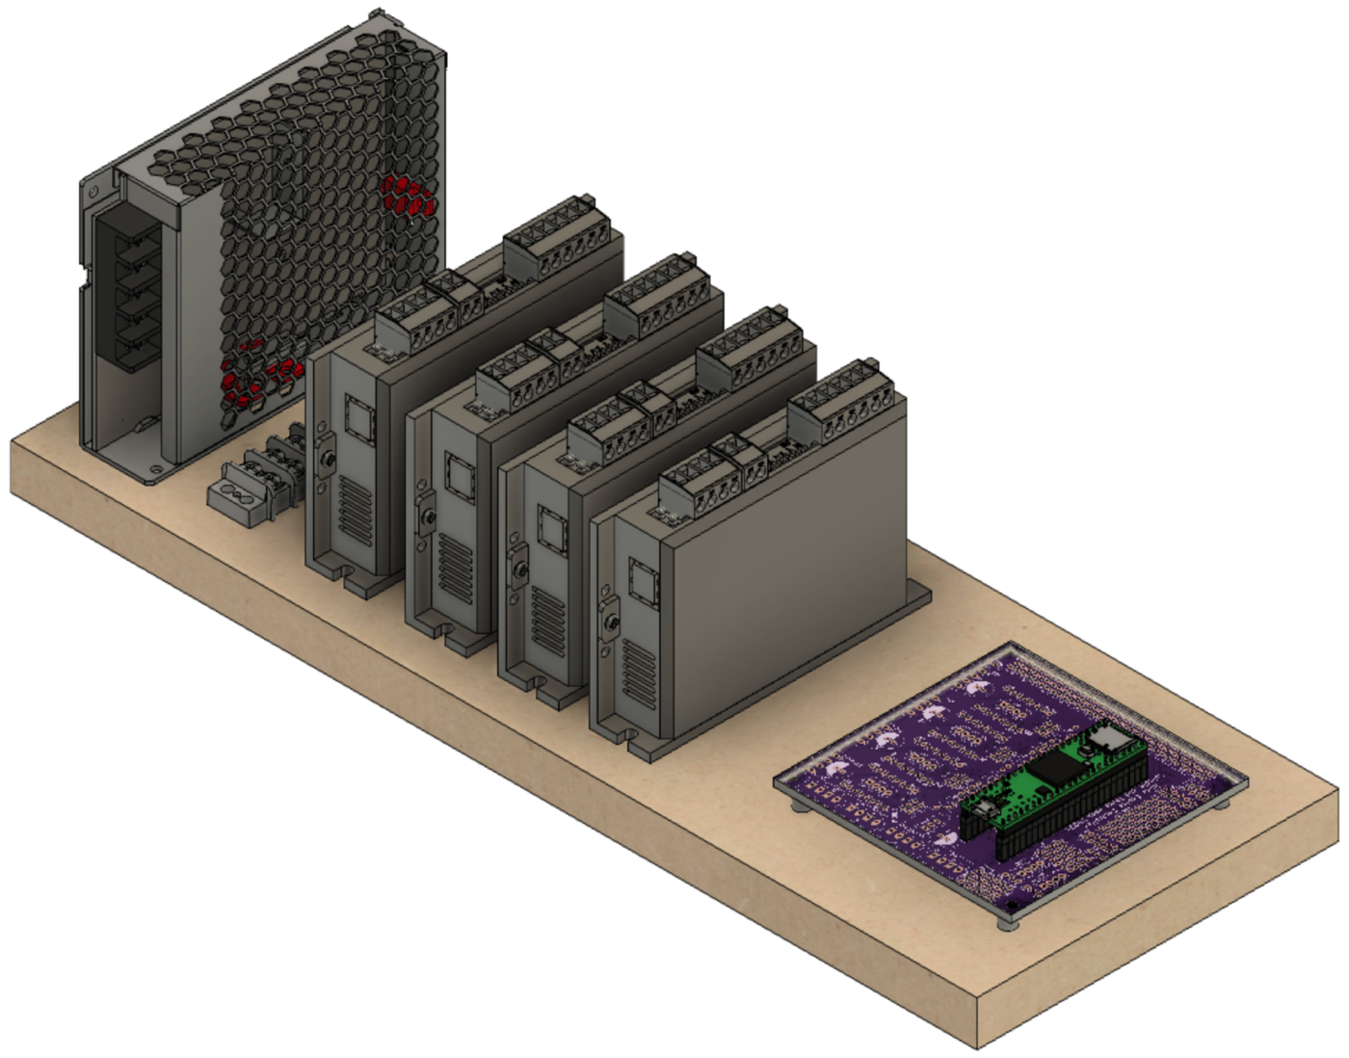

**DM542T – B Axis**

**LRS-100-24**

Spacing between DM542Ts is 1” or so.

**PCB**

(sitting atop spacers)

**DM542T – Spindle**

**DM542T – X Axis**

**DM542T – Z Axis**

**Terminal Block**

|  |
| --- |
| Section 4 – Power Cables |

### Wiring – Power Supply (LRS-100-24)

|  |  |
| --- | --- |
| Conductor Type | Stranded copper |
| Conductor Size | 16 AWG (min) |
| Cable Size | 3 conductors / cable |

#### Power Infeed

The power infeed is connected as:



|  |  |
| --- | --- |
| Wire Color | Power Switch |
| Black Incoming Power | Terminal 1 |
| Black Outgoing Power | Terminal 2 |

|  |  |
| --- | --- |
| Wire Color | LRS-100-24 |
| Black from Power Switch Terminal 2 | L |
| White | N |
| Green | GND (A picture containing drawing  Description automatically generated) |



Black

White

Black

Green

#### A picture containing honeycomb, food, oven Description automatically generatedPower Outfeed

terminal block is used to make the installation and maintenance of the system’s components easer. Using a terminal block allows connections to be added, changed, or removed without the risk of any other connections loosening.

|  |  |
| --- | --- |
| Conductor Type | Stranded or solid copper |
| Conductor Size | 20 or 22 AWG |
| Cable Size | 2 conductors / cable |

One of the power supply’s **+V** outfeeds, and one of the **-V** outfeeds is connected up to the terminal block where the power will be distributed.

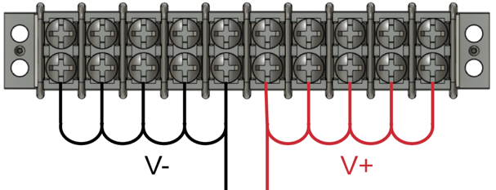

1. **-V** is connected to the other side of the terminal block using a white or black wire. That same colour wire is then used to cascade the -V side of the power to the next 4 terminals.
2. **+V** is connected to one side of the terminal block using a red wire, and then that same colour wire is used to then cascade the +V side of the power to the next 4 terminals.

### Power Cable – 24V Power Supply to PCB

Screw the power cable wires into the terminal block plug as noted below.

Ensure the wire is long enough to reach the PCB when installed.

|  |  |  |
| --- | --- | --- |
| Terminal Block | Wire Color | PCB |
| +V terminal | Red | ⭘ +24V |
| -V terminal | White | ⭘ -24V |

This is plugged into the power header connector (#112) installed on the PCB (above).



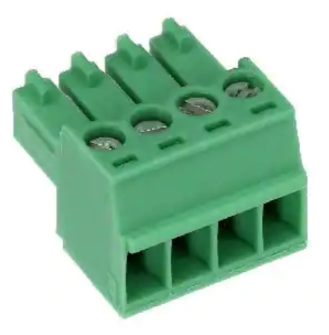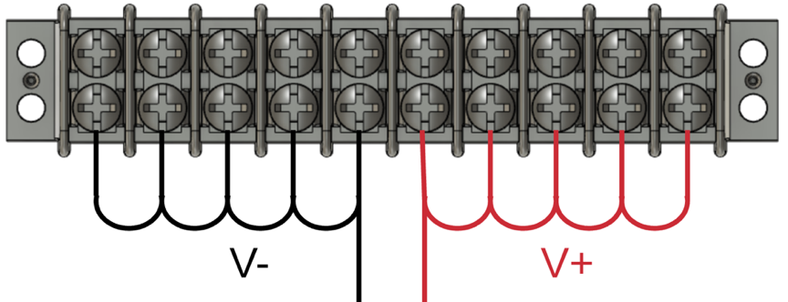

### Power Wiring – DM542T Stepper Motor Drivers (4)

Each of the 4 DM542T stepper motor drivers is connected to the terminal block for power.

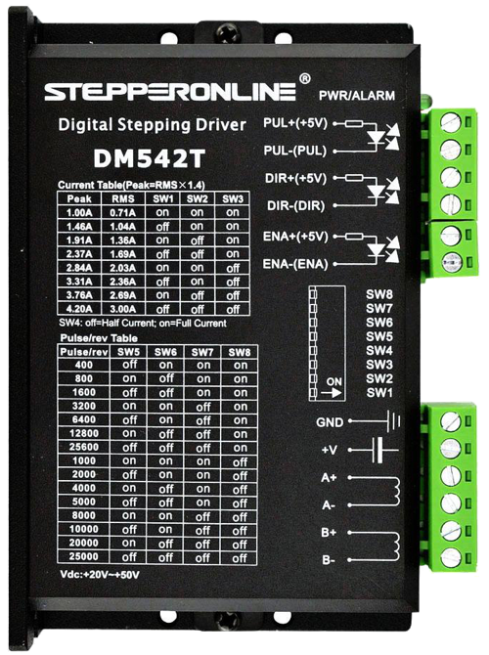

|  |  |  |
| --- | --- | --- |
| Terminal Block | Wire Color | DM542T |
| +V terminal | Red | +V |
| -V terminal | White |  |

|  |  |
| --- | --- |
| Conductor Type | Stranded or solid copper |
| Conductor Size | 20 or 22 AWG |
| Cable Size | 2 conductors / cable |

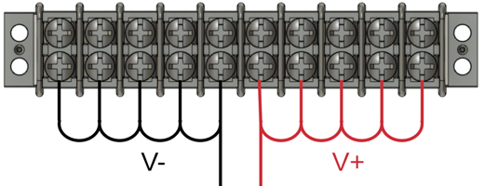

|  |
| --- |
| Section 5 – Stepper Motor Driver Signal Cables |

### Signal Cables – PCB to DM542T Stepper Motor Drivers

Install the pre-crimped ends of the wires into the housing. The other end is connected to the stepper driver as shown below. There are 4 of these.

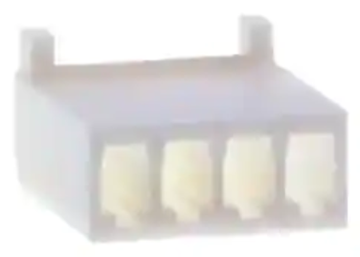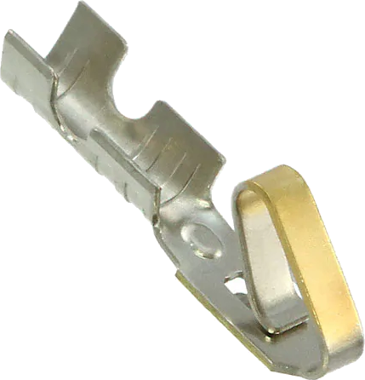

|  |  |  |
| --- | --- | --- |
| DM542T | Wire Color | PCB |
| Direction + | Red | ⭘ DIR |
| Direction - | White (GND) * | ⭘ GND |
| Enable + | Yellow | 🞎 ENA |
| Enable - | White (GND) * | ⭘ GND |
| Pulse + | Black | ⭘ STEP/PUL |
| Pulse - | White (GND) * | ⭘ GND |



A ratcheting/crimping plier for terminal pins makes the attachment of the terminal ends (#310) much easier.

The one I use is made by [IZOKEE](https://www.amazon.sg/IZOKEE-Ratcheting-Terminals-0-1-1-5mm2-Connectors/dp/B0793T3L2D).

* GND wires tied / bonded together.

**NOTE:** two jumpers will be needed to connect the GNDs on each DM542T. One GND wire comes from the PCB, but it needs to connect to all the negative side connectors on the DM542T driver.

### Signal Wiring –Stepper Motor Drivers to GX-16/4 Jacks (4)

Each of the 4 stepper motors is connected to the stepper motor drivers via GX-16/4 Jacks.

|  |  |  |
| --- | --- | --- |
| DM542T | Wire Color | GX-16/4 Pin |
| A+ | Black | 1 |
| A- | Yellow | 2 |
| B+ | Red | 3 |
| B- | White | 4 |

|  |  |
| --- | --- |
| Conductor Type | Stranded copper |
| Conductor Size | 20 AWG |
| Cable Size | 4 conductors / cable |
| Cable Length | 6 to 8” |



**KEY POINT:** It is best to solder the FX-16/4 jacks to the cables and attach the jacks to the metal plate before attaching the other end to the DM542T stepper motor driver. This is a lot easier.

**NOTE:** When soldering wires to the GX-16 jack, it is a good practice to put a small dab of soldering flux onto the terminal before beginning the soldering. This will help it happen faster, minimizing the chance for damage to the jack.

Put flux here

Don’t put too much

flux onto the terminals as

boiling it off when soldering

could cause the terminal to get

too hot, damaging the jack.

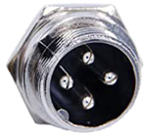

1

2

3

4

## Switch Settings

Set the switches on the DM542Ts as:



|  |  |  |  |
| --- | --- | --- | --- |
| Purpose | Set to | Switch | Setting |
| Current | 2.8A Peak  2.03A RMS | 1 | ON |
| 2 | ON |
| 3 | OFF |
| Half Current | 4 | OFF |
| Pulses / Rev | 6400 | 5 | OFF |
| 6 | ON |
| 7 | OFF |
| 8 | ON |

The current could be set higher with this driver; however, the selected NEMA 23 stepper motor does not need that, so it is set thusly.

**NOTE:** switch settings in the picture are not correct – this is a stock photo from the Internet. Use the settings in the table above.

|  |
| --- |
| Section 6 – Nextion Display Signal Cable |

### Why use a Separate Jack Type for the Nextion Display?

It is a really good idea to have a different connector for the stepper motors than the Nextion touch screen display.

|  |  |  |
| --- | --- | --- |
|  | Nextion Touch Screen Display | Stepper Motors |
| Cable Use | * Serial communications * Power to the display | * Motor stepping, but at a higher voltage |
| Risk if Hooked Up Wrongly | * The higher voltages will probably cause the display to fail. | * The motors will certainly work * May damage the motor. |
| Recommended Connector | * GX-12/4   + Being 12mm in diameter makes the plug not able to connect to the GX-16/4 jack. | * GX-16/4   + Being 16mm in diameter makes the plug not able to connect to the GX-12/4 jack. |
| Optional Connectors | * Could use a GX-16 with more than 4 connectors (e.g., GX-16/5). The additional pins will just be unused, but this would prevent plugging the plug into the wrong jack. * RJ-45 | * n/a |

### Signal Cable – PCB to Nextion Display

The Nextion touch screen is connected to the PCB via GX-12/4 connector.

**KEY POINT:** It is best to

1. Solder the jack to the cables
2. Install the jack into the 2-gang plate.
3. Once that is in place, then insert the pre-crimped ends into the housing.

This is a lot easier.

Green Wire

TX

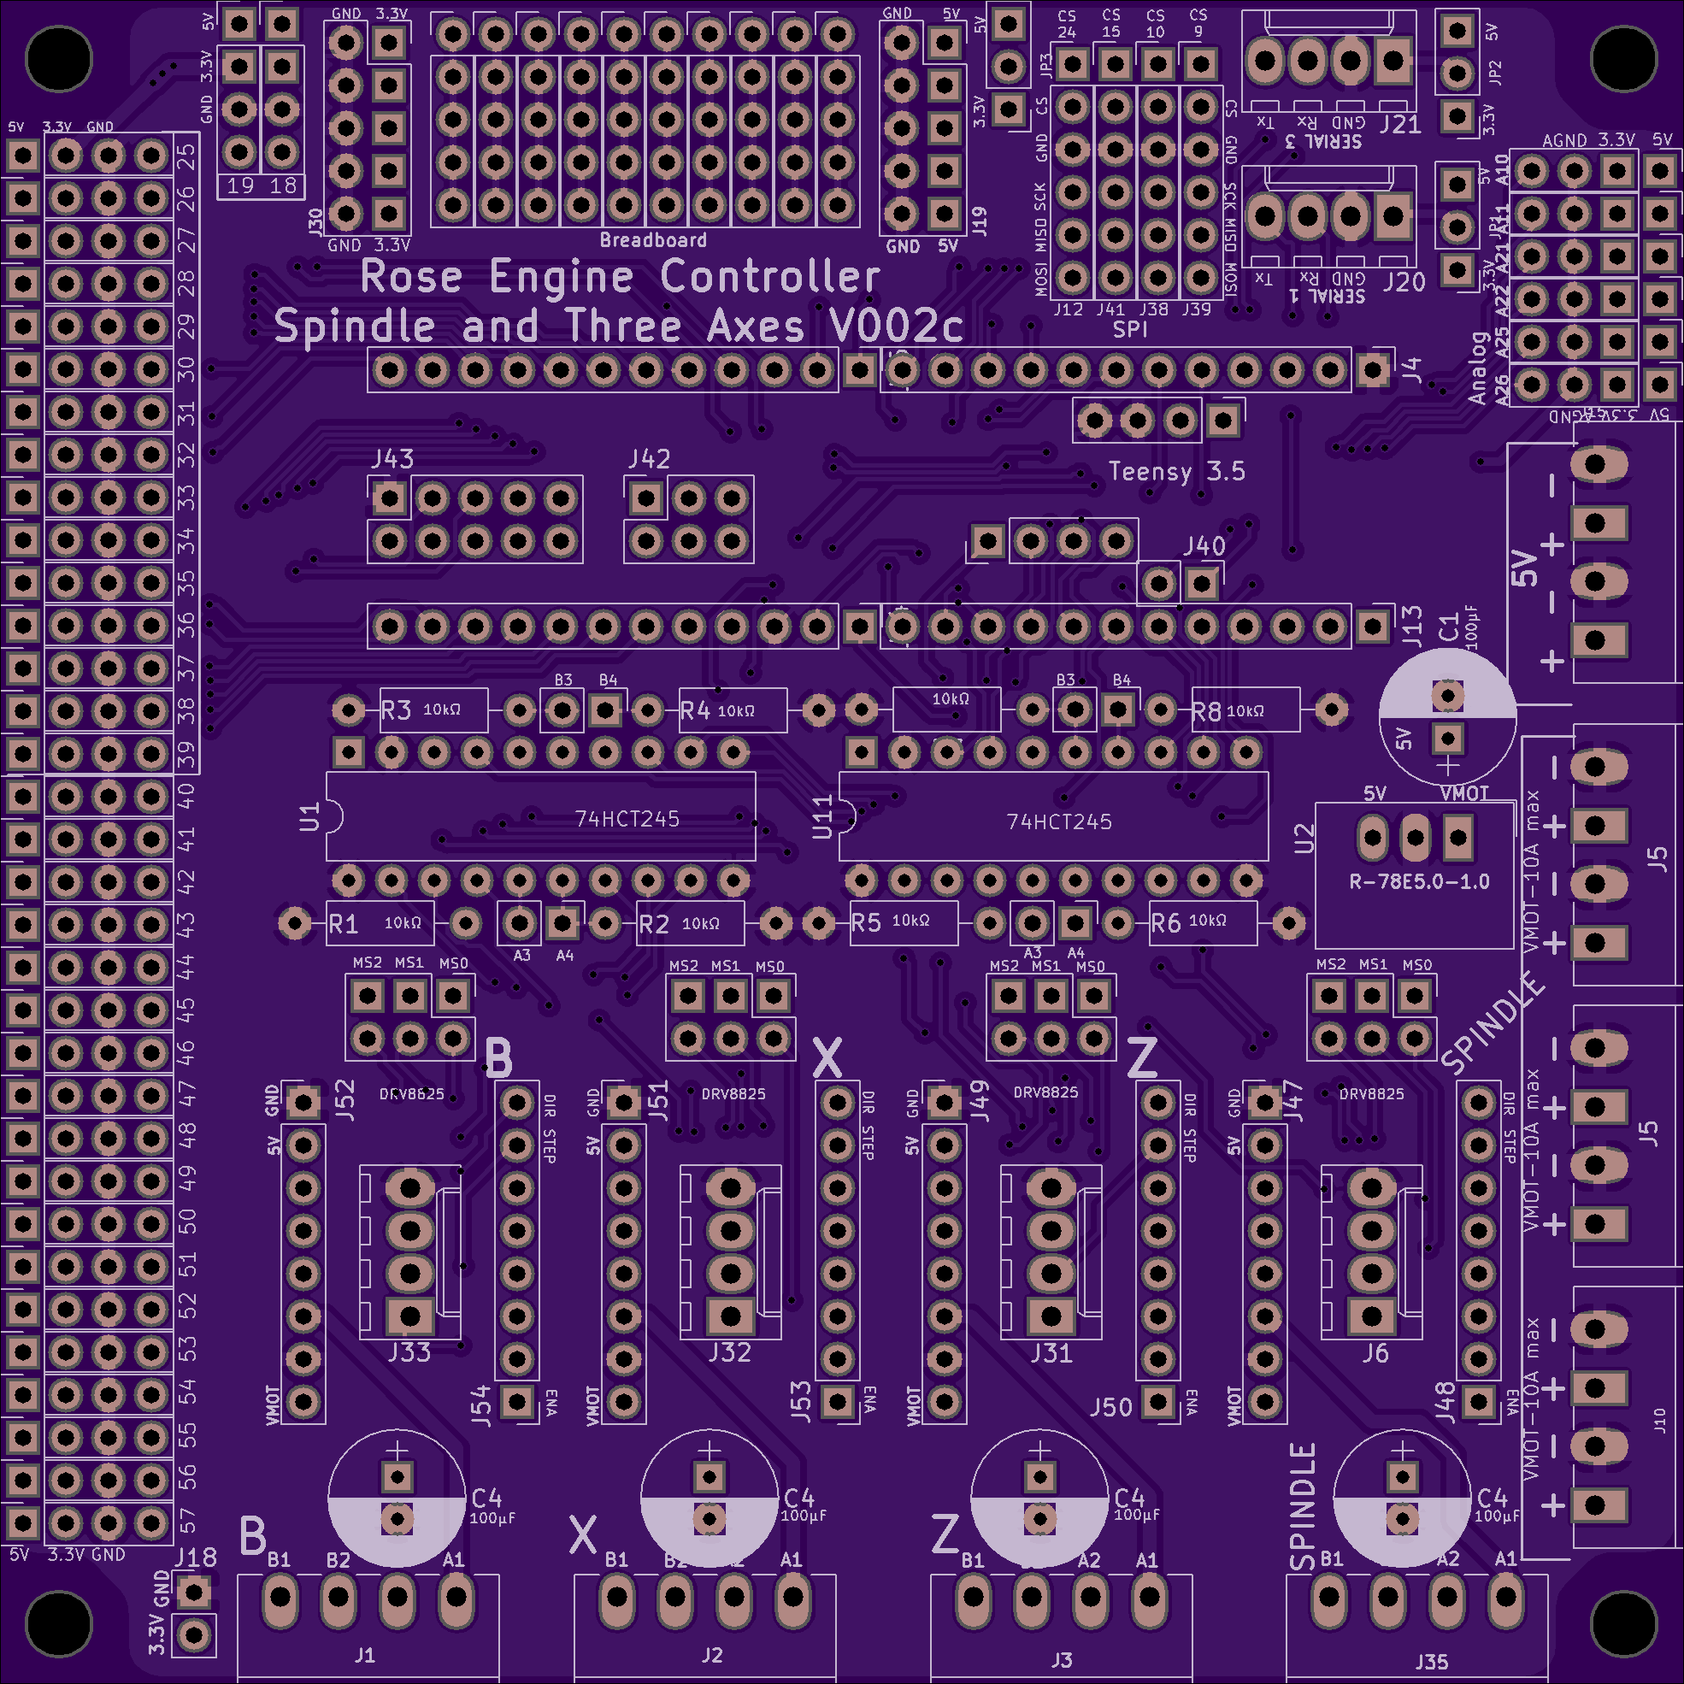

**NOTE:**

* Tx on the PCB is connected to Rx on the touch screen.
* Rx on the PCB is connected to Tx on the touch screen

Rx

Tx

**Nextion HMI Display**

Tx

Rx

**PCB**

White Wire

GND

Blue

Wire

RX

Orange

Wire

+5V

Tx = 1

Rx = 3

GND = 4

+5V = 2



### Signal Cable – PCB to Nextion Display



Install the pre-crimped wires into the housing. There are 4 of these.



Orange

Wire

+5V

White Wire

GND

Blue

Wire

RX

Green Wire

TX

|  |
| --- |
| Section 7 – Limit Switch Signal Cables |

### Signal Wiring – PCB to 3.5mm Audio Jacks for Limit & Home Switches

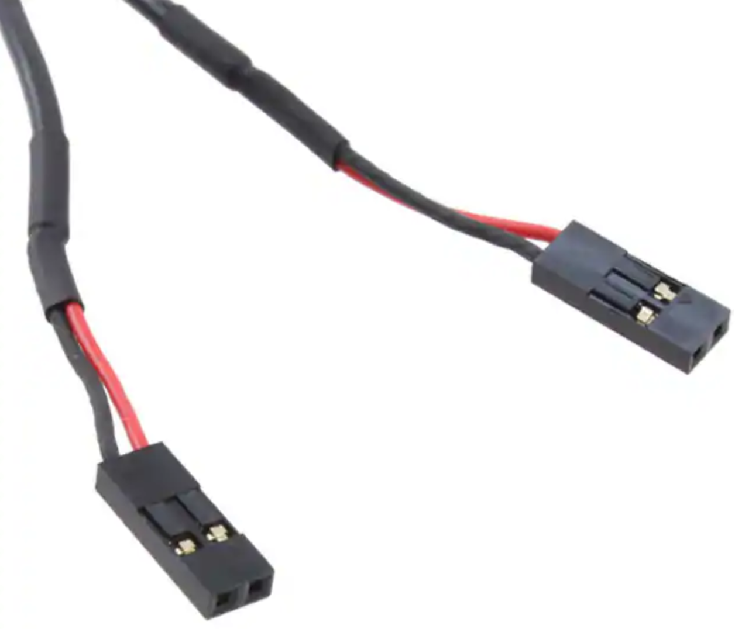

The limit switches are connected to the PCB via a 3.5mm (1/8”) audio female jack. 6 pins on the Teensy are used (one for each limit switch). These can be any of the pins between 25 and 39.

The cable used is half of part #305.

|  |  |  |
| --- | --- | --- |
| PCB | Wire Color | Audio Jack |
| ⭘ pin # | Red | Tip / pin 2 |
| ⭘ GND | White or Black | Sleeve / pin 1 |

Actual length is 9 ¾”

(only one jack is shown)

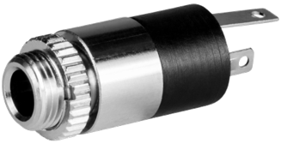

2 - Tip

1 - Sleeve



**NOTES:**

1. Most audio jacks that are available are stereo with 3 connectors. Only 2 are needed, so the 3rd one will go unused.
2. Experience has shown that it is a good practice to ensure a mono plug will work correctly for the way you have soldered the connections.

**KEY POINT 2:** It is a really good idea to label each cable with the pin it is used for.

**KEY POINT 1:** The sleeve must be connected to ground (GND). Typically, this is pin 1, but check based on the jack you are using.

Connect the cables to the header pins. The recommended pins are noted below, but any between 25 and 39 can be used.



**25**

**26**

**27**



**28**

**38**

**39**

Inside = pin # = Red wire

Outside = GND = Black wire

|  |
| --- |
| Section 8 – Final PCB Steps |

### A circuit board Description automatically generatedMounting the PCB to the MDF Board

The Teensy microcontroller is installed onto the PCB as shown in the picture to the right.

The two 74HCT245 integrated circuits are installed as shown in the picture to the right. Note that the indicating mark should be on the left side.

A microSD extension cable, 8 to 12 inches long, is useful. The male end can be put into the Teensy’s microSD slot, and the female end can then be hung out of the case. This makes it easier to access files for the screens where that function is possible.

**MicroSD Extension Cable**

|  |
| --- |
| Section 9 – Stepper Motor Cables |

Each of the stepper motors is connected to the stepper motor drivers via GX-16/4 plugs. Stepper motor wire colors shown are for the StepperOnline motors. Check that the one you use matches for the connection needed.

|  |  |  |  |
| --- | --- | --- | --- |
| Stepper Motor | Stepper Motor Wire | Cable Wire Color | GX-16/4 Pin |
| A+ | Black | Black | 1 |
| A- | Green | Yellow | 2 |
| B+  1  2  3  4  B-  B+  A-  A+  **GX-16/4** | Red | Red | 3 |
| B- | Blue | White | 4 |

|  |  |  |
| --- | --- | --- |
| Conductor Type | | Stranded copper |
| Conductor Size | | 20 AWG |
| Cable Size | | 4 conductors / cable |
| Cable Length | |  |
|  | Spindle | 4 ft |
|  | Others | 3 ft, or as desired |

Put a ¾” long piece of shrink file onto each one of the stepper motor wires before connecting it to the cable 5 wires.

Connect the cable wires to the stepper motor wires using a lineman’s splice (AKA, the Western Union splice, and shown to the right), and then solder the two together.

Heat the shrink file tubing around each of the joints to insulate it from the other things it could touch.

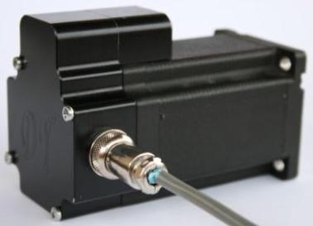Alternatively, you can add a back cover to the stepper motor. This gives a secure way to attach the signal wires to the motor. These are available from a number of sources, and they can even be 3D printed. Look for one online using the term “stepper motor back cover”.

In this case, connect the stepper motor to the GX-16/4 jack as:

|  |  |  |
| --- | --- | --- |
| Stepper Motor | Stepper Motor Wire | GX-16/4 Pin |
| A+ | Black | 1 |
| A- | Green | 2 |
| B+ | Red | 3 |
| B- | Blue | 4 |

|  |
| --- |
| Section 10 – Attaching the Stepper Motor to the Headstock |

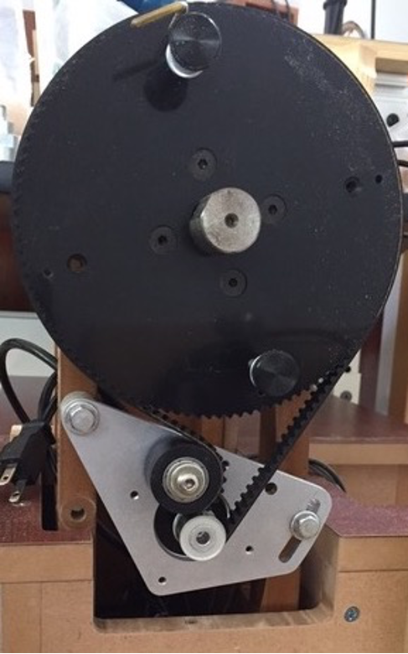

The stepper motor attaches to the headstock as shown in the picture to the right.

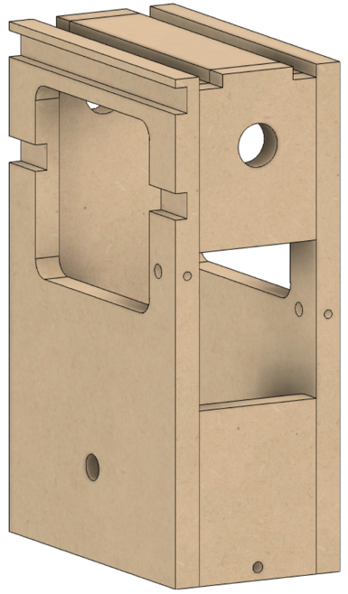

If you purchased the kit we supply, the holes on the left and right are already set properly. If you built it yourself, you will now need to drill the holes for the screws on the right. As noted in the case building instructions, these need to be set based on the alignment of the bracket.

Attach the spindle pulley to the spindle flange. There are 4 screws for this. One is indicated here.

Attach the stepper motor to the bracket using 4 screws. One is indicated here.

Secure the 12-tooth drive pulley to the stepper motor’s spindle.

Attach the bracket to the headstock on both sides. There are two screws and two spacers (they look like thick washers). The spacers are installed between the bracket and the headstock. They are held onto the headstock using barrel nuts. Do not tighten them just yet.

Install the timing belt (item #501).

**NOTE:** The picture on the right is of the assembly on the original MDF rose engine lathe. On version 2.0, there is no need for the cutout in the base to accommodate the bracket.

Snug the bracket so that the timing belt is tight enough that it won’t slip, but not so tight that it stretches. Once it is set, tighten the two bolts holding the bracket to the headstock. They need to be tight enough to not slip, but don’t over tighten them as that will cause the barrel nuts to pull thru the MDF.

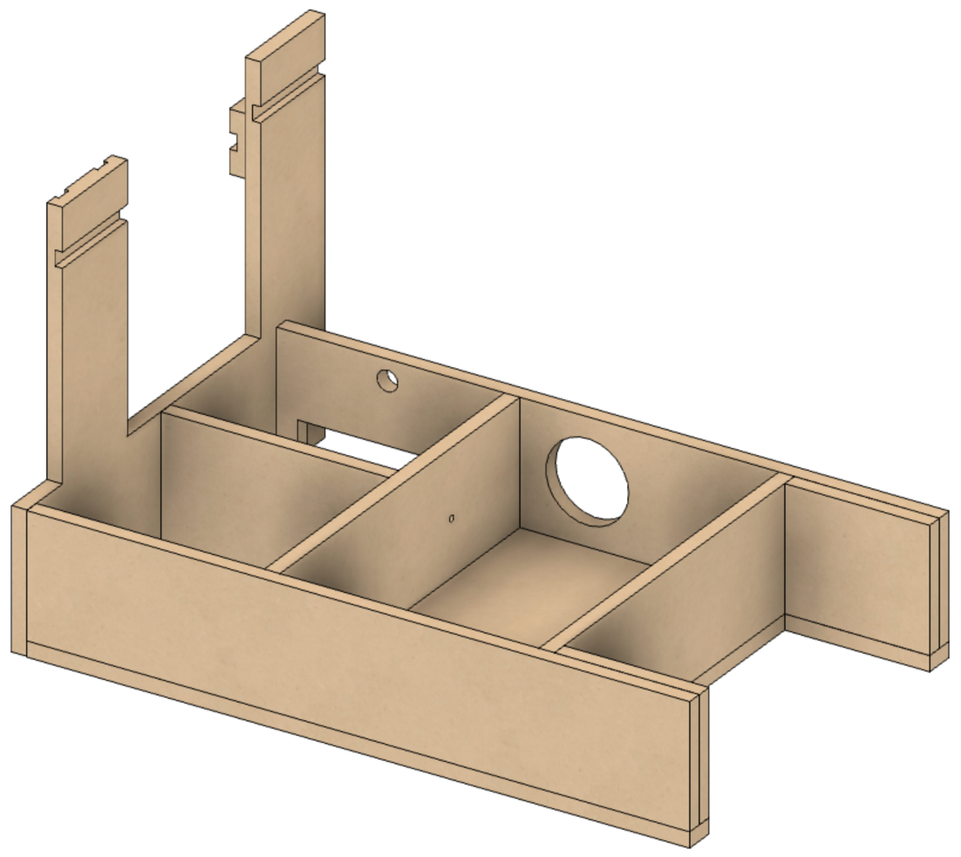The stepper motor’s cable needs to be fed thru the hole in the back of the headstock,

and continue out of the lathe thru the hole in the back of the bed.

|  |
| --- |
| Section 11 – Assembly of the Nextion touch screen Box |

## A screenshot of a computer screen Description automatically generatedAttach Nextion Display to the Bezel

One hole is printed into the back side of the bezel for attaching the Nextion touch screen (circled in red to the right). That one needs to be enlarged using a #39 drill to a depth of 1/8”.

Attach one corner of the Nextion touch screen using an M3 Thread Forming Screw, then center the HMI. Drill the other 3 corners, and then attach the display using the remaining M3 Thread Forming Screws.

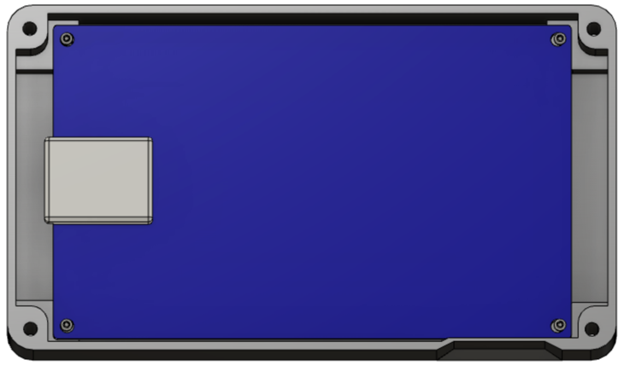

Note that the Nextion is inserted upside down. This is because the microSD card slot is then pointed down. And the microSD card slot is accessible so that upgrades can be done without having to disassemble the whole system. (The slot for inserting the microSD card is in the base, not the bezel.)

### A close up of a computer Description automatically generatedAttach Parts to the Base

Attach the 4 magnets to the base’s bottom. There are 4 insets in the base for these.

If the screws protrude into the base, take some efforts to grind or file those sharp points down.

### A picture containing sitting, electronic, monitor, oven Description automatically generatedInsert the Heat-Set Inserts

There are two options here:

1. Using a heat gun, insert each of the heat-set inserts into the corners of the base. These would then be used to attach the top of the case using the 4-40 screws (#403).  
     
   If you plan to disassemble the box and reassemble it quite a bit, this is probably the way to go. Otherwise, take option #2 (it is much easier.
2. Do nothing at this point, and attach the top using thread forming screws (#410)

### Add Wire Cord Grip

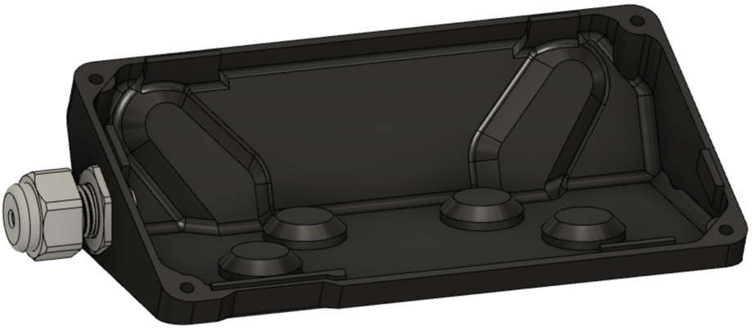The cord grip is used to ensure the signal wire does not pull against the Nextion display.

Depending on the printing, you may need to drill the whole with a ½” bit to ease the installation.

### Signal Wiring – PCB to GX-12/4 or RJ-45 Plug for Nextion Display

|  |  |  |  |  |
| --- | --- | --- | --- | --- |
| Nextion Connection | Nextion Wire Color | CAT 5  Wire Color | GX-12/4  Pin | RJ-45  Pin |
| RX | Yellow | White/Green | 1 | 1 |
| +5V | Red | Green | 2 | 2 |
| TX | Blue | White/Orange | 3 | 3 |
|  |  | Blue |  | 4 |
|  |  | White/Blue |  | 5 |
| GND | Black | Orange | 4 | 6 |
|  |  | White/Brown |  | 7 |
|  |  | Brown |  | 8 |

The Nextion touch screen is connected to the main box via a GX-12/4 or RJ-45 connector.

Using a piece of CAT 5 (or greater) wire, 8 feet long, make the connections to the HMI’s connector (supplied by the vendor) as shown to the right.

**NOTE:** Be sure to put the cable thru the cord grip (#212) before attaching both ends.

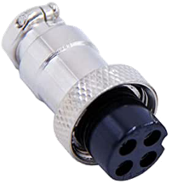

1

3

2

4

**GX-12/4**

Put a ¾” long piece of shrink file onto each one of the Nextion wires before connecting it to the CAT 5 wires.

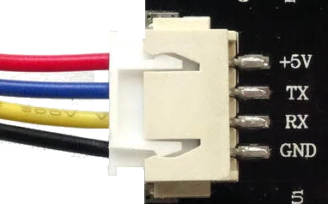

**Nextion Display**

Connect the CAT 5 wire to the Nextion wires using a lineman’s splice (AKA, the Western Union splice, and shown to the right), and then solder the two together.



**Lineman’s Splice**

Heat the shrink file tubing around the joint to insulate it from the other things it could touch.

|  |
| --- |
| Section 12 – System Setup and Program Loading |

Use the web page noted below to load the programs into the Teensy and the Nextion, and then load the initial configuration into the Teensy.

[](https://mdfre2.colvintools.com/NextionUserGuide-Upgrading.html)

<https://mdfre2.colvintools.com/NextionUserGuide-Upgrading.html>

If you are looking for that book on the MDF Rose Engine Lathe 2.0 Library, it is just like the book shown to the right.

|  |
| --- |
| Section 13 – Finishing It Up |

Before screwing the bezel to the base, check to be sure everything works. To do that, you will need to use the instructions in the next section to load the programs into all the pieces.

or

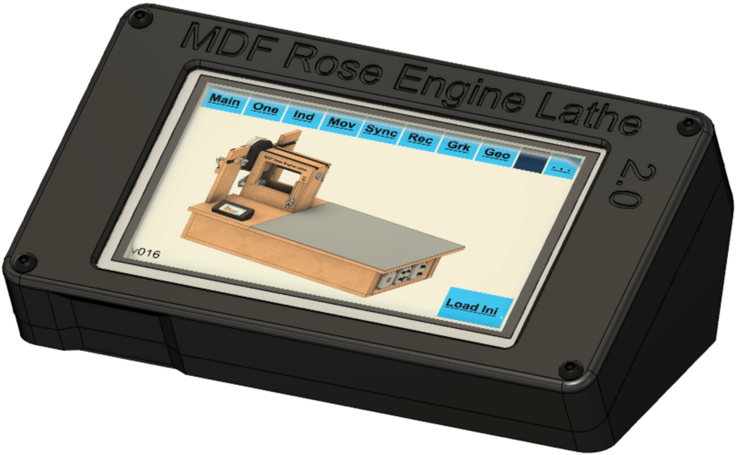

If it works, screw the two pieces together.

If you took the option to use the heat set inserts back on pg. 50, then attach the lid using four #4-40, ¾” long screws (#403).

Otherwise, attach it using 4 thread-forming screws (#410).

When finished and powered on, it will look like the picture to the right.

# Optional Configurations

If you wish to change the designs built into this system, options are outlined below. ***We do not support systems with such changes, so the user must be aware that they will be responsible for their own technical support.*** These options are only provided for the sake of completeness and transparency.

## Option 1: Less Functional Model

|  |  |  |  |  |
| --- | --- | --- | --- | --- |
|  | **Configuration** | | | |
| **Component** | **Spindle Drive Only** | **+ Z Axis** | **+Z & B Axes** | **+Z, X, and B Axes** |
| 10 KΩ Resistors | 4 | 4 | 8 | 8 |
| 74HCT245s &  20-pin DIP sockets | 1 | 1 | 2 | 2 |
| DM542T Stepper motor drivers &  GX-16/4 Jacks | 1 | 2 | 3 | 4 |

Some have expressed the desire to build a system which is not as fully functional as outlined in this document. For example, they only want to drive the spindle.

That is very doable but is not an option we will be providing. The components which can be left out when building the system are outlined in the table below.

Regarding limit switches, none are truly required. These can be added later as desired. If not used, the 3.5mm audio jacks are not needed.

### Recommendation

Except for the DM542T Stepper Motor Drivers, there really is not any significant cost advantage to taking this approach. So, if you do desire to make such a change, consider populating the Printed Circuit Board fully (8 resistors and two 74HCT245s). The DM542Ts can be added when you later want to expand to use them.

## Option 2: Alternative Stepper Motor Drivers

The printed circuit board was developed to use either

* the DM542T external drivers outlined above, or
* the Pololu DRV8825 stepper motor drivers which would be attached to the board using header sockets.

### Advantages to Using the Pololu DRV8825

1. DRV8825s are about 1/3 the cost of an external driver (i.e., the DM542T).
2. Having the DRV8825s mounted to the printed circuit board makes for a smaller physical footprint, enabling it to be installed easily inside the lathe’s bed carcass.
3. The power draw for this configuration is lower, so a different (& potentially less expensive) power supply is possibly available.
4. There is less cabling to be done.

### Disadvantages of Using the Pololu DRV8825

1. DRV8825 chips are limited to a max 1.5 A (vs. 4.2 A for the DM542T drivers).
   1. This can necessitate the need for different, more expensive stepper motors. The cost of these different motors can erode the savings for not using the external stepper motor drivers (DM542T).
   2. It is easy to overload the DRV8825 chips and cause them to fail.
   3. It is easy to overload the DRV8825 chips and they in turn can cause other components to fail (e.g., the Teensy).
2. DRV8825 chips get hot when used, so fans must be attached to them to ensure they do not overheat. And the user will need to replace the fans when they fail.
3. Future deliverables (e.g., a curvilinear slide and a spherical slide) for the MDF Rose Engine Lathe 2.0 will be tested to ensure compatibility with the design from above. If the add-on devices do not work with the changed configuration, the owner/builder will be responsible for accommodating the necessary changes.

### Recommendation

Unless you are an electrical / automation engineer or have substantial experience in this space, the design outlined with external stepper motor drivers will be easier to implement over the long term.

## Option 3: Different Microcontroller

The printed circuit board was developed to use either

* the Teensy 3.5 outlined above, or
* the Teensy 3.6.

The Teensy 3.6 is 50% faster than the 3.5; however, it will only accommodate 3.3V whilst the Teensy 3.5 will accommodate 5V. Using the 3.5 helps ensure you don’t burn out the microcontroller.

As for Teensy 4.0 or 4.1, the library of functions needed to control the stepper motor drivers is not yet complete for those boards. We will re-evaluate those over time.

### Recommendation

Unless you are an electrical / automation engineer or have substantial experience in this space, the design outlined with a Teensy 3.5 is recommended.

## Option 4: Different Display

The control system was designed for a 4.3” Nextion display. We provide the code for both the original 4.3” Enhanced display and the 4.3” Intelligent display.

Redoing the displays to accommodate a larger display (5” or 7”) is being considered. However, that is a lot of work so it will not be coming soon.

### Recommendation

Use the Nextion 4.3” Intelligent display.

# Document Version History

|  |  |  |
| --- | --- | --- |
| Ver | Date | Comment |
| 2.1 | 14 Aug 21 | * Changed pins used for limit switches * Added information regarding different Teensy and Nextion displays. |
| 2.0 | 13 Jun 21 | * This document incorporates changes to the way cables are attached to the PCB. It now shows how to use connectors in lieu of soldering the wires directly to the board. |
| 1.4 | 10 Mar 21 | * Reorganized a few steps to follow better flow of work. * Added notes on using GX-12/4 connector for Nextion display. * Updated instructions for loading software to reference web site. * Also added a few minor other tweaks. |
| 1.3 | 01 Jan 21 | * Added item numbers for optional build using a Pololu Tic (this is a separate document). * Renamed Document |
| 1.2 | 15 Dec 20 | * Added parts to the bill of materials * Added details on the installation of the 3.5mm phono jacks. |
| 1.1 | 10 Dec 20 | * Added details for optional configurations. * Added information for attaching the stepper motor to the headstock |
| 1.0.2 | 07 Dec 20 | * Updated p/n for item #204; also updated p/n & qty for item #102. * Added note on soldering on 3.5mm jacks first. |
| 1.0.1 | 05 Dec 20 | * Updated commentary about stepper motor needed. * Added information about stepper motor mount, pulleys, and belt. * Updated drawing dimensions. |
| 1.0 | 01 Dec 20 | Initial document |

To the extent that material may appear to be infringed, we assert that such alleged infringement is permissible under fair use principles in U.S. copyright laws. If you believe material has been used in an unauthorized manner, please contact me at [ColvinTools@Gmail.com](mailto:ColvinTools@Gmail.com).

The layout of the Printed Circuit Board (PCB) is copyright Ed French and is used with his permission.

Permission is not granted to manufacture these for sale.